dthcbz 1.69

BYCNHERWBZ

GJ J<CKE:BDFYB?

pphu „KME” Marek Kuklis
ul/ Osiedlowa 4a
95-100 ZGIERZ
tel/ (0-42) 719 - 05 - 70
fax (0-42) 719 – 05 - 71
tel/ kom/ (0-601) 22 - 69 - 61

e-mail: kme@kme/com/pl
http://www/kme/com/pl

CTYNZ<HM 2000

CJLTH:FYBT

Lbfuyjcrjg KME 3
Ddtltybt 4
Jcyjdyjt jryj ghjuhfvvs „LBFUYJCRJG 5
Pfgecr ghjuhfvvs 6
Gthtlyzz cntyrf ecnhjqcndf 6
Ht;bvs hf,jns 7
Ghjbpdtltybt bpvthtybq 7
Dhtvz d bpvthtybz[ 8
Bpvthbnkmyst rfyfks - ht;bv Htubcnhfnjh#Lbfuyjcrjg 9
Eybdthcfkmysq rfyfk 12
Rfkb,hjdrf 12
Bycnhevtynfkmyst ryjgrb 13
Gthtvfnsdfybt 14
Hfcgjkj;tybt ghj,tujd 15
Yektdjq ehjdtym 15
Vfhrths 16
Pfgbcm b jncxbnfybt lfyys[ 17
Ecnfyjdktybt ghjuhfvvs 18
Hf,jnf c rjyabuehfwbzvb 19
Vtytl;th rjyabuehfwbb 22
<fpjdsq rfnfkju rjyabuehfwbb 23
Bvgjhnbhjdfybt rjyabuehfwbb 24
"rcgjhnbhjdfybt rjyabuehfwbb 25
Gtxfnfybt 27
Egjnht,ktybt vtcnf [hfytybz 28
Pfvtxfybz 28
Nht,jdfybz gj [fhldthe b j,jheljdfybt 29
Nt[ybxtcrbt lfyyst 30

Lbfuyjcrjg KME
Ghbcnfdrdf gthtvtyz/ofz gthcjyfkmysq rjvgm/nth PC d lbfuyjcnbxtcrbq cntyl ∋ktrnhjyys[ c[tv d fdnjvfibyf[.

Lbfuyjcrjgs 'nj ecnhjqcndf rjnjhst lf/n djpvj;yjcnm vt;le ghjxbv yf,k/lfnm 'ktrnhbxtcrbt ghj,tub cbuyfkjd rjnjhst dscnegf/n dc/le nfv ult yjcbntktv byajhvfwbq zdkztncz 'ktrnhbxtcrb njr. Cjdhtvtyyst fdnjvj,bkb $afhibhjdfyyst$ ckj;ysv 'ktrnhjyysv ltkjv ghblf/n vt[fybrfv dct ,jkmitt rjkbxtcndj ghj,ktv b nhelyjcntq d elfktybb ytljcnfnrjd. Bvtyyj Lbfuyjcrjg zdkztncz gjvjxysv ecnhjqcndjv b lf;t ytj,[jlbvsv ghb gjxbyrf[ dghscrjds[- b cbcntv pf;bufybz b nfr;t lheub[ fdnjvj,bkmys[ 'ktrnhjyys[ c[tv.
Lbfuyjcrjg d vfcnthcrjq zdkztncz yt njkmrj j,ktuxtybtv lkz vt[fybrf yj nfr;t gjkmpjq rkbtynfv. Ghbywbgs rjyrehtynyjcnb dct d ,jkitq cntgtyb dcnegf/n d cbke nfr;t b d fdnjvj,bkmyjq jnhfckb. Dlfltkmwfv cthdbcjd ytj,[jlbvj cnfnm exbnsdfnm nj> xnj rkbtyns rjnjhst gj ght;ytve ,skb kjzkmyst - dlheu vjuen j,hfnbnmcz pf gjvjom/ d cjctly// !kexit j,jheljdfyye/ vfcnthcre/. Bpj,hf;tybt abhvs d ukfpf[ rkbtynf bvttn ,jkmijt pyfxtybt lkz ghb,skb abhvs. Tckb hf,jnybrb abhvs hf,jnf/n ghjatccbjyfkmyj kjdrj bcgjkmpez ghb 'njv cjdhtvtyyst lbfuyjcnbxtcrbt bycnhevtyns #njulf ljdthtyyjcnm r abhvt hfcntn f pfntv gjcktljdfntkmyj hfcntn b lj[jl#.
Abhvf "KME" zdkztncz bpujnjdbntktv Lbfuyjcrjgf d dblt ghbcnfdrb r rjvgm/nthe PC. Gjxtve vs ds,hfkb nfrjt ;t htitybt*
Djn ytcrjkmrbt ghbxbys%
- Nfrbv j,hfpjv vs bcgjkmpetv rjvgm/nth PC, rjnjhsq> rfr ghfdbkj> ceotcndetn d ,jkmibycndt vfcnthcrb[. Lkz hf,jns c Lbfuyjcrjgjv vj;yj bcgjklmpjdfnm rjvgm/nth c ytdscjrbvb nt[ybxtcrbvb gfhfvtnhfvb rjnjhsq lj cb[ gjh bcgjkmpjdfkcz kbim njkmrj lkz cjcnfdktybz afrneh b dtltybz crkflf.
- Ytdschjrfz wtyf lbfuyjcrjgf -–ghbcnfdrb #wtys byntuhbhjdfyys[ lbfuyjcrjgjd vyjuj hfp dsit#.
- Jyj lftn ,jkmibt hfcxtnyst djpvj;yjcnb dsntrf/obt bp pfgfcjd PC #ghjuhfvvf lftn djpvj;yjcnm pfgbcfnm ytjuhfybxtyyjt rjklbxtcndj ,fp lfyys[ cjlth;fob[ 'ktrnhbxtcrbt ghj,tub b bpvthbntkmyst rjyabuehfwbb.
- Ghbznyjt j,cke;bdfybt ghjuhfvvs dsntrf/ott c cjandthf lkz Windows (3/xx/95/98).
- Ghjuhfvve> rjnjhfz fyfkbpbhetn lfyyst dsckfyyst c ghbcnfdrb d rjvgm/nth vj;yj kturj cfvjve ghbcgjcj,bnm r bylbdblefkmysv gjnht,yjcnzv #nfre/ djpvj;yjcnm lftn cfvf ghjuhfvvf# bkb vj;yj pfrfpfnm bpvtytybz bpujnjdbntk/ yfgh. lkz gjnht,yjcntq cthdbcyjq ctnb #bpujnjdbntkm cjplfk d ghjuhfvvt ytcrjkmrj ltcznjr ecnfyjdktybq lkz ghjdthjr 'ktvtynjd dghscrjds[ cbcntv b cbcntv pf;bufybz rjnjhst [fhfrnthbcnbxtcrbt lkz jnltkmys[ cbcntv b fdnjvj,bkmys[ vfhjr rfr ;t b lkz cnfylfhnys[ bpvthtybq#.
- Djcvj;yjcnm ghjbpdjlbnm bpvthtybz dj dhtvz tpls yf fdnjvj,bkt d n.y. ljhjujdjv ntcnt #egjhnt,kzz gthtyjcysq rjvgm/nth - notebook#.
- Dctj,ott ghbcencndbt rjvgm/nthjd d ghjcdtnbntkmys[ exht;ltybz[ lftn djpvj;yjcnm bcgjkmpjdfnm lbfuyjcrjg d ext,ys[ wtkz[ #yf jcyjdfybb xtnsht[ jlyjdhtvtyyj jnxthnsdfyys[ lbfuhfvv kturj gjyznm dpfbvjcdzpb dscnegf/obt vt;le jnltkmysvb ntcnbhjdfyysvb 'ktvtynfvb#.
- Ghjuhfvvf lftn gjnht,bntk/ djpvj;yjcnm j,hfpjdfnm cj,cndtyst bpvthbntkmyst rjyabuehfwbb #ecnfyjdktybz# c cfvjcnjzntkmyj ghblfyysvb yfbvtyjdfybzvb. Gjkextyyst bpvthtybz vj;yj pfgbcfnm d gfvznb rjvgm/nthf lkz lfkmituj fyfkbpf bkb rfr [fhfrnthbcnbxtcrbt ghj,tub> rjnjhst vjuen cke;bnm rfr bpvthbntkmyst j,hfpws> jghtltkz/obt ghfdbkmye/ bkb ytghfdbkmye/ hf,jne bccktljdfyys[ 'ktvtynjd.
Lbfuyjcrjg KME j,kflftn hzljv aeyrwbq jnhf;f/ob[ tuj chtlb ecnhjqcnd 'njuj nbgf yfghbvth%
- Htubcnhfwbz jlyjdhtvtyyj xtnsht[ vtlktyyj bpvtyz/ob[cz ghj,tujd, pf chjr lj 30 vbyen#. Nfrjq ht;bv hf,jns ecnhjqcndf lftn djpvj;yjcnm j,yfhe;fnm ytnbgbxys[ gjdht;ltybq dscnegf/ob[ njkmrj byjulf#.
- Lkz njxyjuj fyfkbpf 'ktrnhbxtcrb[ ghj,tujd ytj,[jlbvf cbcntvf vfhrthjd. Vfhrth vuyjdtyys[ pyfxtybq lftn djpvj;yjcnm jncxbnsdfnm pyfxtybz jcb „Y” jlyjdhtvtyyj c xtnsht[ rfyfkjd n.t. yfghz;tybt> njr, xfcnjnf, lfdktybt, dfreevlfdktybt, ntvgthfnehe, dhtvz hfcrhsnbz dghscrbdfntkz> j,#vby b lheubt. Vfhrths lkz bpvthtybz dhtvtyys[ ghjvt;enrjd „Δt”[ms] b xfcnjns „f”[Hz].
- Ceotcndetn djpvj;yjcnm cjltqcndbz c ljgjkybntkmysvb bpvthbntkmysvb bynthatqcfvb bpujnjdkztvsvb abhvjq KME #ghbcnfdrfvb#> rjnjhst lf/n djpvj;yjcnm rjvgktrcyj bpvthznm hf,jxbt gfhfvtnhs ldbufntkz% lfdktybt lj 18 <fhjd #yfuytnfybz d wbkbylhf[> lfdktybz vfckf> njgkbdf# dfreevlfdktybz #d rjkktrnjht dcfcsdfybz#> ntvgthfnehs> yfnz;tybz njrf #yfgh. gecrf> pfhzlrb#> jrbcb eukthjlf d ds.[kjgys[ ufpf[, ghj,tu lfdktybz dghscrf njgkbdf d Lbptkmys[ ldbufntkz[.
Lbfuyjcrjg KME zdkztncz wtyjdjq b rfxtcndtyyjq fkmnthyfnbdjq lkz lheub[ ecnhjqcnd 'njuj nbgf.

Ddtltybt
Ghjuhfvvf ”Lbfuyjcrjg” d cjxtnfybb c lbfuyjcnbxtcrbv ecnhjqcndjv lftn nt,t djpvj;yjcnm cj,k/lfnm> fyfkbpbhjdfnm> htubcnhbhjdfnm 'ktrnhbxtcrbt ghj,tub dscnegf/ibt d 'ktrnhjyys[ b 'ktrnhjnt[ybxtcrb[ ecnhjqcndf[ d fdnjvfibyf[. D nj ;t dhtvz Ds vj;tnt cj,k/lfnm dgkjnm lj xtnsht[ bccktljdfyys[ ghj,tujd> lkz ,jktt crjhjcnys[ ghj,tujd Ds vj;tnt bcgjkmpjdfnm ghjuhfvve rfr wbahjdsq jcwbkjcrjg. Dct htubcnhbhjdfyyst ghj,tub Ds vj;tnt pfgbcfnm c wtkm/ gjplytqituj fyfkbpf #b[ rjkbxtcndj juhfybxbdftncz njkmrj dvtcnbvjcnm/ lbcrf d rjvgm/ntht. Lkz vfrcbvfkmyjuj eghjotybz ds,jhf ecnfyjdktybq ghjuhfvvf lftn Nt,t djpvj;yjcnm cjplfnm yf,jhs xfot dct[ egjnht,kztvs[ rjyabuehfwbq bpvthbntkmys[ rfyfkjd d rf;ljv ht;bvt hf,jns b ,scnhj b[ ds,hfnm #gj [fhfrnthyjv yfbvtyjdfybb#. Ds vj;tnt nfr;t cjplfdfnm ghbvthyst lbfuhfvvs b [hfybnm b[ dvtcnt c ecnfyjdktybzvb rjyabuehfwbb yfgh. rfr j,hfpws. R gfrtnt ghbrk/xbkbcm ytcrjknrj ltcznjr cnfylfhnys[ ecnfyjdktybq, rjnjhst Ds vj;tnt vjlbabwbhjdfnm cjjndtncndtyyj cdjbv gjnht,yjcnzv. Lheubt ghbvths b nfr;t rjyabuehfwbb Ds vj;tnt yfqnb yf yfitq dbnhbyt ctnb Bynthytn: www/kme/com/pl

Ghb gjvjob „Lbfuyjcrjgjv” vj;yj vt;le ghjxbv cjdthifnm jncxbnfybz%
- Ghtj,hfpjdfntktq: MAP, MAF, TPS, gmtpjrthfvbxtcrb[ (yfgh/ lfnxbr ltnjyfwbb njgkbdf),
- Lfnxbrjd rbckjhjlf #pjyl #, Halla, vfuybnj'ktrnhbxtcrb[, jgnbxtcrb[ #yfgh. cbcntvs pf;bufybz ABS/ETS/DSC#>
- Dhtvtyb hfcrhsnbz dghscrbdfntkz bkb gjkj;tybt bvgekmcyjuj ldbufntkz d ecnhjqcndf[ LPG #kbytqyst lbfuhfvvs#>
- J,jhjnjd rjktyxfnjuj dfkf ldbufntkz #c exntybtv rjkbxtcndf wbkbylhjd#>
- 'kernhjvfuybnys[ rkfgfyjd yfgh: elfktybz djple[f ldbufntkz (EGR), eghfdktybz vtlktyysvb j,jhjnfvb, htwbhrekzwbb ds[kjgys[ ufpjd> dghscrbdfntkz>
- gthtlfxb lfyys[ (CAN Bus),
- ntcnjd frevekznjhf, cnfhnthjd> fkkmnthyfnjkhf,
- cbcntv pf;bufybz> #gthdbxys[> dnjhbxys[#,
- ntreotuj njrf b jnyjcbntkmyjq rjvghtccbb wbkbylhjd #c egjnht,ktybtv njrjds[ rktob#,
- b vyjuj lheub[

Ecnhjqcndj ghbr/cftncz r rjvgm/nthe IBM PC gjchtlcndjv gjhnf ghbynthf (LPT).
Ghjuhfvvf cjj,oftncz c ecnhjqcndjv> ghjbpdjlbn bpvthtybz b ghtlcnfdkztn b[ yf bynebnbdysq cgjcj, yf lbcgktt. Pfntv b[ vj;yj yfgtxfnfnm bkb gthtckfnm d [hfytybt b bcgjkmpjdfnm d lheujq ghjuhfvvt.

Jcyjdyjt jryj ghjuhfvvs „LBFUYJCRJG
Yb;terfpfyysq xthnt; ghtlcnfdkztn jcyjdyst 'ktvtyns ghjuhfvvs> c rjnjhsvb Dfv ghbltn hf,jnfnm.
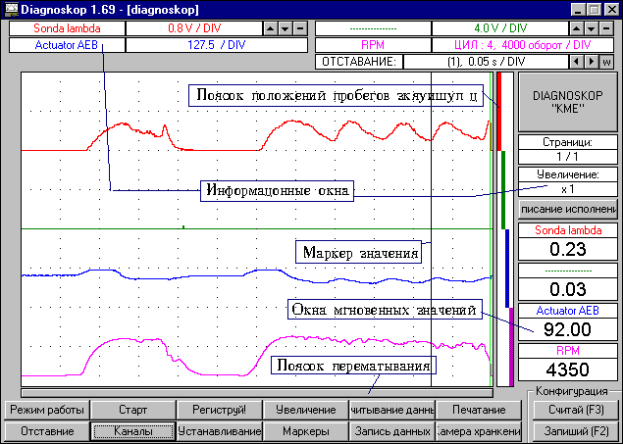
- Lbcgktq – hhjtrnbgetn dsgjkyz/obt Dfvb bpvthtybz.
- Gjkjcrf gjkj;tybq ghj,tujd - erfpsdftn Dfv rfre/ xfcnm jryf lbcgktz pfybvf/n ghj,tub.
- Ryjgrb ds,jhf aeyrwbb – lf/n Dfv djpvj;yjcnm gjl,hfnm ht;bv hf,jns> yfxbyfnm> b rjyxfnm bpvthtybz> rjyabuehjdfnm bpvthbntkmyst rfyfks> pfgbcsdfnm b jncxbnsdfnm lfyyst > ds,bhfnm edtkbxtybt> cdtnjrjgbhjdfnm vfhrths.
- Byajhvfwbjyyst jryf – ghjtrnbhe/n ds,hfyst Dfvb d njn vjvtyn ecnfyjdktybz.
- Vfhrth pyfxtybz b nfr;t rehcjhs dhtvtyb jrfpsdf/n Dfv gjvjom d fyfkbpt bpvthtybq
- Jryf vuyjdtyys[ pyfxtybq – ghjtrnbhe/n pyfxtybz bpvthtybq lkz ds,hfyyjuj Dfvb ghjvt;enrf dhtvtyb> erfpsdf/n nj;t ntreobt pyfxtybz ghjbpdjlbvs[ bpvthtybq.
- Gjkjcrf grthtvfnsdfybz - erfpsdftn Dfv rfre/ xfcnm lfyys[ Ds d lfyysq vjvtyn cj,k/lbnt yf lbcgktt.

Pfgecr ghjuhfvvs

Lkz ghjdj;ltybz bpvthtybq [dfnbn ghbrk/xbnm ecnhjqcndj r gjhne ghbynthf b pfgecnbnm ghjuhfvve. Jyf ghjdthztn r rjnjhjve gjhne ghbrk/xtyf ghbcnfdrf. Tckb ecnhjqcndj ghfdbkmyj ghbrk/xtyj b gbnftncz njulf yf lbcdktt rjvgm/nthf zdbncz jcyjdyjt jryj ghjuhfvvs $LBFUYJCRJG$. D lheujv ckexft ghtrnbhetncz jryj c byajhvfwbtq j jncencndjdfybb cjtlbytybz c ghbcnfdrjq bkb jncencndjdfybz gbnfybz. Gjckt tuj pfvryenbz ryjgrjq "OK" zdbncz juryj ghjuhfvvs. Pfntv cktletn njxyj ghjdthbnm cjtlbytybz c rjvgm/nthjv b gbnfybtv #cdtxtybt rhfcyjuj lbjlf gbnfybz yf gthtlytq cntyrt ecnhjqcndf#, ds,hfnm ryjgrjq $Ecnfyjdktybz$ jryj ecnfyjdjr b ghjbpdtcnb ltntrwb/ gjhnf #cvjnhb Ecnfyjdktybt ghjuhfvvs#.
Ds,jh gjhnf zdkz6tncz jcyjdyjv lkz ghfdbkmyjq cjdvtcnyjq hf,jns ghjuhfvvs c ecnhjqcndjv. Rjvveybrfwbz gjchtlcndjv ds,hfyyjuj gjhnf gjpdjkztn ghjuhfvvbhjdfnm ecnhjqcndj #v. gh. ds,bhfnm ltkbntkb yfghz;tybz/. C dnjhjq cnjhjys ghjufvvfr jncxbnsdftn xthtp gjhn bpvthbntkmyst lfyyst c ecnhjqcndf Gjckt ecnfyjdrb ghjuhfvvs htrjvtyletncz pfgbcfnm ntreobt lfyyst j abhvtm, rjnjhst ,elen d lfkmytqitv gjvtofnmcz d pfukfdbb rf;ljq hfcgtxfnrb #'nb cghfdrb vj;yj nfr;t ddtcnb gjp;t#.

Gthtlyzz cntyrf ecnhjqcndf
Aeyrwbjyfkmyfz rjynhjkmyfz kfvgjxrf
DF:YJT!!! Jgbcfybt aeyrwbjyfkmyjq rjynhjkmyjq kfvgjxrb:
Eybdthcfkmyjt cjtlbytybt
-Rhfcysq wdtn j,jpyfxftn> xnj ltqcndetn eybdthcfkmyjt cjtlbytybt (d ht;bvf[ lbfuyjcrjg#htubcnhfnjh/ Cbuyfks lkz rfyfkjd A b C ,thencz njkmrj xthtp 'nj cjtlbytybt.
-Ptktysq wdtn j,jpyfxftn> xnj ltqcnde/n cjtlbytybz bylernbdyjuj b tvrjcnyjuj pjylf #d ht;bvt jcwbkjcrjgf#
-Lbjl yt cdtnbncz – frnbdyst cjtlbytybz A, B, C, D-bylernbdysq pjyl lkz ht;bvf Lbfuyjcrjg#htubcnhfnjh bkb A b B lkz ht;bvf jcwbkjcrjg.

Ht;bvs hf,jns
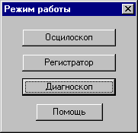
D ghjuhfvvt „Lbfuyjcrjg” nhb ht;bvs hf,jns%
- jcwbkjcrjg>
- htubcnhfnjh>
- lbfuyjcrjg.
Rf;lsq bp ht;bvjd [fghfrnthbpetncz jnltkmysv cgtwbfkmysvb cgjcj,jv ghjdj;ltybz bpvthtybq.
D ht;bvt „jcwbkjcrjg” Ds vj;tnt bccktljdfnm ,scnhj bpvtyz/obtcz ghj,tub jn lde[ bpvthbntkmys[ rfyfkjd.
D ht;bvt „htubcnhfnjh” Ds vj;tnt pfrfpfnm htubcnhfwb/ dgkjnm lj 31,200 bpvthtybq (65 cnjhjy lbcgktz) jn xtnsht[ bpvthnntkmys[ rfyfkjd, j,kflfz hfpkbxysvb crjhjcnzvb ghjbpdtltybz bpvthtybz b nfr;t yf,k/ltybt bpvthztvs[ ntreob[ pyfxtybq. "nj lftn Dfv djpvj;yjcnm gtht[dfnbnm ytghfdbkmyjcnb dscnegf/obt vjvtynfkmyj d ntxtybt bpvthtybq.
Ht;bv „Lbfuyjcrjg” ghb,kb;ty r ht;bve „htubcnhfnjh”, yj jy bcgjkmpetn kbim njkmrj jlyj> gthbjlbxtcrb $pfwbrkbdfyyjt$ jryj lbcgktz. Jyj gjpdjkztn Dfv ,tcgtht,jqyj yf,k/lfnm pf bpvthtybzvb rjulf yt yflj htubcnhbhjdfnm cnjkm ,jkmituj rjkbxtcndf lfyys[.
D rf;ljv bp ht;bvjd hfm,jns Ds vj;tnt pfgbcfnm yf lbcrt d rjvgm/ntht ghjdtltyyst bpvthtybz> f pfntv jncxbnfnm b[ lkz ghjdj;ltybz fyfkbpf.
Lkz ds,jhf jlyjuj bp ht;bvjd hf,jns> ghjcnj yf;vbnt ryjgre „Ht;bv hf,jns” b d bpj,hf;tyyjv jryt ds,thbnt nht,etvsq ht;bv.

Ghjbpdtltybt bpvthtybq
Lkz yfxfkf bpvthtybq d ht;bvf[ „jcwbkjcrjg” b „lbfuyjcrjg” yf;vbnt ryjgre „Cnfhn ”. Jyf njulf gthtvtybncz d ryjgre „Cnjg”, ghb gjvjob rjnjhjkq Ds vj;tnt ghtrhfnbnm ghjdj;ltybt bpvthtybq. Pflth;fnm bpvthtybz Ds vj;tnt nfr;t yf;bvfz ryjgre [Esc] yf rkfdbfneht.
D ht;bvt „htubcnhfnjh” tckb [jnbnt cnfnm bpvthznm, yf;vbnt ryjgre „Yjdst bpvthtybz” – njulf Ds cvj;tnt ecnfyjdbnm rjkbxtcndj bpvthtybq rjnjhjt ghjdtcnb ghjuhfvvjq. Dj dhtvz bvthtybq Ds vj;tnt nfr;t egjnht,kznm ryjgrb „Cnjg” b „dyjdm” dgkjnm lj vjvtynf> rjulf ghjuhfvvf bcgjkybn pfrfpfyyjt Dfvb rjkbxtcndj bpvthtybq.
D ht;bvt „Lbfuyjcrjg” dscnegftn nfr;t djpvj;yjcnm crjhj gthtqnb r htubcnhfwbb bpvthtybq. Lkz 'njuj yf;vbnt ryjgre „Htubcnheq!” – ghgjugfvvf vtybn ht;bv hjf,jns yf „utubcnhfnjh” b rjgbhetn jryj yjds[ bpvthtybq, ljcnfnjxyj> xnj,s Ds gjlndfthlbkb b[ bcgjkytybt. Ghjuhfvvf gjlcrfpsdftn 5 cnhfybqw bpvthtybq> ghb xtv ght;lt xtv gjlndthlbnm Ds vj;tnt cvtybnm 'nj xbckj.
D ntxtybt bpvthtybq ghjbpdjlbvs[ d ht;bvt "jcwbkjcrjgf" gjkmpjdfnmcz vsim/ vj;tn ,snm ljdjkmyj nhelyj. Lkz cvtys ecnfyjdktybq ghrtrhfnbnt ghjbpdj;ltybt bpvthtybq yf;bvfz rkfdbi [S] bkb [Esc].

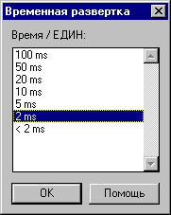
Dhtvz d bpvthtybz[
D ht;bvt „$jcwbkjcrjg$ Ds vj;tnt ds,hfnm cjjndtncndtyye/ lkz ghjbpdjlbvs[ Dfvb bpvthtybq dhtvtyye/ hfpdthnre. Lkz 'njuj yf;vbnt ryjgre „$Dhtvtyyfz hfpdthnrf$. Vbybvfkmyfz dhtvyyfz hfpdthnrf pfdbcbn jn crjhjcnb rjvgm/nthf c rjnjhsv Ds hf,jnftnt. Vj;tnt nj;t ghjbpdjlbnm bpvthtybz c yfb,jkmitq ljcnegyjq crjhjcnm/ #gthtl xbckjv dscnegftn pyfr vtymitcndf < .

D ukfdyjv jryt Ds fr;t vj;tnt cvtyznm dhtvtyyye/ hfpdthnre c egjnht,ktybtv ryjgjr hfcgjkj;tyys[ e dth[ytuj bajhvfwbjyyjuj jryf.

Lkz ht;bvf „Lbfuyjcrjg” Ds ds,bhftnt lfyyjt jncnfdfybt gjckt yf;fnbz ryjgrb „Jncnfdfybt$ lkz ht;bvf „htubcnhfnjh” – gjckt yf;fnbz ryjgrb „Yjdst
bpvthtybz”.

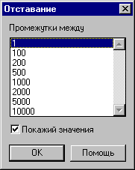
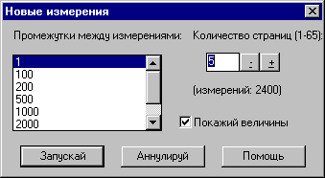

Jncnfdfybz lkz ht;bvjd "htubcnhfnjh" b "Lbfuyjcrjg" hfccxbnsdf/ncz ghjuhfvvjq d rjkbxtcndt jncnfdf/ob[ bpvthtybq. Ds vj;tnt nfrt;t vtyznm jncnfdfybt rfr ;t b b ghjtrwb/ vuyjdtyys[ pyfxtybq d jcyjdyjv jryt ryjgjr hfcgjkj;tyys[ e dth[ytuj byajhvfwbjyyjuj jryf.
Cktletn pfvtnbnm> xnj bp-pf hbcjdfybz ntreob[ byajhvfwbq d jryt lbcgktz> yt vj;yj njxyj ghbyznm dhtvtyb> s rjnjhjv ,elen ghjbpdjlbnmcz bpvthtybz. Dvtcnj njuj gjckt jrjyxfybz rjvhktrcf rjgbhetncz byajhvfwbz j j,(tvt dhtvtyb> rjnjhjt ,skj ytj,[jlbvj #dth[ytt byajhvfwbjyyjt jryj#. Rhjvt njuj rf;ljt bp ghjbpdjlbvs[ bpvthtybq pfrk/xftn byajhvfwb/ j vjvtynt dhtvtyb> d rjnjhjv jy ,sk ghjbpdtlty f pfntv ghjvt;enrb dhtvtyb Ds vj;tnt bpvthznm njxyj #yfgh vfhrthfvb#.


D 'nb[ ht;bvf[ Ds vj;tnt nfr;t ghjtrnbhjdfnm pyfxtybz ghjbpdjlbvs[ bpvthtybq. Ljcnfnjxyj lkz 'njuj tckb Ds j,jpyfxbnt htitnre „Ghjtrnbheq pyfxtybz$ b rhjvt jlyb[ ghj,tujd cvj;tnt yf,k/lfnm d jryf[ vuyjdtyys[ pyfxtybq htubcnhbhjdfyyst htpekmnfns.

Ghjtrwbz vuyjdtyys[ pyfxtybq ghb ghjdjlbvs[ bpvthtybz[ #j,jpyfxtyyjt htitnrj „Ghjtrnbheq pyfxtybz$# pfvtlkztn ghjbpdj;ltybt bpvthtybq#. Tckb drk/xbnm ghjtrwb/ pyfxtybq – vj;yj ljcnbuyenm pfvtxfntkmysq 'aatrn – dhtvz dsgflf/ott yf ltktybt ghb yfbvtymitv jncnfdfybb evtymibncz #hzljv jr. 100ms/DIV – d pfdbcbvjcnb jn crjhjcnb hfmjns rjvgm/nthf #. <kfujlfhz njve Ds cvj;tnt yfghbvth htubcnhbhjdfnm ljdjkmyj crjhjcnyst ghj,tub, ,tc gtht[j;ltybz d ht;bv „jcwbkjcrjg”.

Bpvthbnkmyst rfyfks - ht;bv Htubcnhfnjh#Lbfuyjcrjg
Ghjuhfvvf lftn Dfv nj;t djpvj;yjcnm ghbcgjcf,kbdfnm ecnfyjdktybz bpvthbntkmys[ rfyfkjd pfdbcbvj jn htlbvf hf,jns. Lkz dspdfybz jryf rjyabuehfwbb rfyfkjd yf;vbnt ryjkgre „Rfyfks$ bkb rkbryent ghfdjq ryjgrjq vsib ult-nj d jryt lbcgktz.
Lkz ht;bvf „jcwbkjcrjg” e Nt,z ldf bpvthbntkmys[ rfyfkf #4 lbfgfpjys bpvthztvs[ pyfxtybq> bpvthtybz gjkj;bntkmys[ b jnhbwfntkmys[ pyufgxtybq# b nfr;t ecnfyjdktybz jnyjczobtcz r cby[hjybpfwbb. Tckb drk/xbnm cby[hjybpfwb/> c ktdjq cnjhjys lbcgktz gjzdbncz gjfpfntkm cby[hjybpfwbb> rjnjhsq Ds vj;tnt gthtldbufnm c egjnht,ktybtv vsiwb.

Lkz cjdthitybz bpvthtybq ghb gjvjob bylernbdjq b tvrjcnyjq pjyljd dj dnjhbxyjq cbcntvt pf;bufybz cktletn d jryt „Rfyfks” ht;bvf „jcwbkjcrjg” drk/xbnm jgwbjy „tvrocny/ b bylernbdy pjyls”. Gjckt gjlndth;ltybz #ryjgrjq „OK”# 'nj ,eltn cbuyfkbpbhjdfnmcz cvtyjq wdtnf aeyrwbjyfkmyjuj lbjlf d ptktysq #yf gthtlytq cntyrt ecnhjqcndf#.
D njv ;t cfvsv jryt cnfyen jnvtxtys nfr;t gjkz „Ghjtrwbz vfrc/ A” b nfr;t „Ghjtrwbz vfrc / B”/ „"nf aeyrwbz lftn djpvj;yjcnm ghjtrnbhjdfnm vfrcbvfkmyst vuyjdtyyst pyfxtybz b j,keuxftn yf,k/ltybt jnltkmys[ $afqkjd$ #ghbujlyj ghb bpvthtybz[ cbcntvs pf;bufybz gthdbxyjq b dnjhbxyjq#.
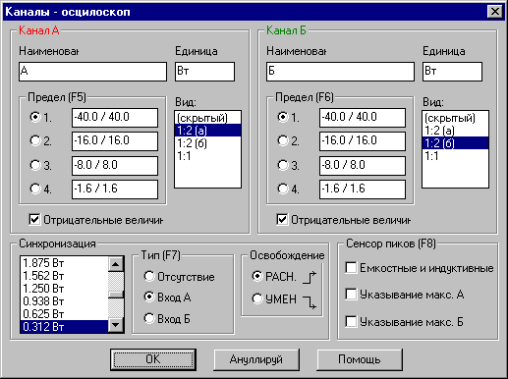

Ecnfyjdktybz „Cby[hjybpfwbz” gjpdjkz/n gjlj,hfnm rfyfk c rjnjhjv cktletn cby[hjybpjdfnm ghjtrwb/ ghj,tuf b nfr;t ehjdtym> gthtcnegktybt rjnjhjuj dspjdtn hbcjdfybt lbfuhfvvs. Vj;yj nfr;t htibnm j njv> d rfrjv gjhzlrt yfxyencz ghjtrwbz% c djphfcnf/otuj (INC) bkb gjyb;f/otujcz (DEC) crkjyf cbuyfkf.
Pyfxtybt yfghz;tybz jnrk/xtybz Ds vj;tnt htuekbhjdfnm nfr;t ytgjchtlcndtyyj d jcyjdyjv jryt Lbfuyjcrjgf. Lkz njuj ghjnzyent vsitq gjrfpfntkm hfcgjkj;ty c ktdjq cnjhjys lbcgktz lj nht,etvjuj ehjdyz #cvjnhb Bycnhevtynfkmyst ryjgrb/.
Bpvthbntkmyst cnhfybws Jcwbkjcrjgf
D Dfibv hfcgjhz;tybb nfr yfp. #sbpvthbntkmyst cnhfybws#. Yy rf;ljq bp yb[ Ds vj;tnt pfgbcfnm bysq ghj,tu #yfghbvth lkz b[ chfdytybz/. D k/,jq vjvtyn Ds vj;tnt gthtrk/xbnmcz yf cktle/oe/ cnhfybwe bpvthtybq yf;bvfz rkfdbi [Page Down] rfr ;t b r gthtlytq cnhfybws yf;bvfz rkfdbi [Page Up]/. „"nb rkfdbib ltqcnde/n yt njkmrj rjulf gthtcvfnhbdftnt pflth;fyyst bpvthtybz, yj nj;t d ntxtybt b[ cjdthitybz.
D ghbvthys[ bpvthtybz[ gjcnfdktyys[ abhvjq KME ,skf pfgbcfyf njkmrj gthdfz bpvthbntkmyfz cnhfybwf. "nj lftn djpvj;yjcnm pfgbcfnm cj,cndtyyst bpvthtybz yf cktle/ob.[ cnhfywf[ b kturjcnm b[ chfdybdfybz. Xbckj ljcnegys[ cnhfbw pfdbcbn jn ds.,hfyyjq dhtvtyyjq hfpdthnrb yfghbvth lkz 100 ms/DIV – jlyf cnhfybwf, lkz 2 ms/DIV - 50 cnhfybw #xnj dsntrftn c rjkbxtcndf dsltktyyjq gfvznb lkz ,eaathf jncxbnfybz#.
Bpvthbntkmyst rfyfks - ht;bv Htubcnhfnjh#Lbfuyjcrjg
Rhjvt rfyfkjd nbgf jcwbkjcrjg #cvfnhb Rfyfks – Jcwbkjcrjg# e Dfc lkz ht;bvjd hrubcnhfnjh b nfr;t Lbfuyjcrjg ldf lj,jdjxys[ bpvthbntkmyjuj rfyfkf% vyjujaeyrwbjyfkmysq rfyfk C b bpvthtybrt j,jhjnjd d rfyfkt D#.
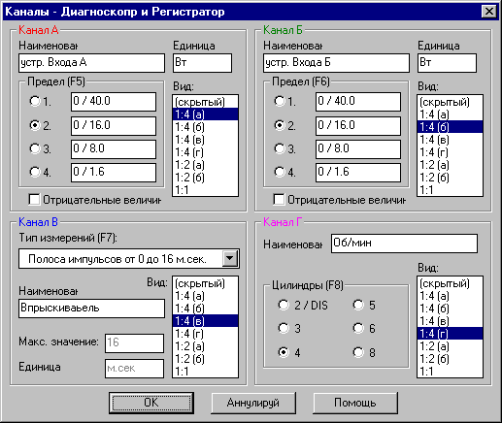
D rfyfkt C ceotcndetn djpvj;yjcnm cvtyznm nbg bpvthtybq#. Lkz njuj ghtlyfpyfxty cgbcjr rjnjhsq hfpdbdftncz gjckt yf;fnbz rkfdbif [F7] bkb ryjgrb „Rfyfks”/. Yfghbvth vj;yj cjdthibnm cktle/obt bpvthtybz%

- chjrf ltqcndbz bvgerkmcjd #jnhbwfntkmys[#,
- Xfcnjns,
- Njrf>

- Rjywtynhfwbb CO d ds.[kjkgys[ ufpf[,
- Djpdhfnyjq cdzpb (feedback)
AEB,
- Ntvgthfnehs,
- Dfreev-lfdktybz,
- Lfdktybz,
- Yfghz;tybz/

Rfyfk D yfpyfxty lkz bpvthtybz j,jhjnjd rjktyxfnjuj dfkf ldbufntkz. Dj dhtvz bpvthtybz bglernbdysv pjyljv vouen dscnegfnm jib,rb d bpvthtybz[ #kbybz lbfuhfvvs c ythjdysvb rhfzvb bkb ghb cvtyt j,jhjnjd lbfuhfvvf yf vtyztncz#. Jyb vjuen ,snm dspdfys hfpkbxysvb nbgfvb 'rhfybhjdfyys[ rf,tktq dscjrjuj yfghz;tybz yfghbvth 'rhfybhjdfyyst bkb c ,jkmijq htpbcnfywbtq. Nfrbt jibmrb vjuen nfr;t dscnegbnm> rjulf vs lbfuyjpbhetv cbcntve pf;bufybz ytnbgbxyjuj htitybz #yfgh. TwinSpark (ldt cdtxb yf wbkbylh)/
D nfrjv cexft cktletn dpznm cbuyfk ytgjchtlcndtyyj jn vbyecf rfneirb pf;bufybz> c dsdjlf vjlekf pf;bufybz> jn lfnxbrf Ufkkf bkb bylernbdyjuj #gjpbwbb dfkf, bkb fgfhfnfg pf;bufybz#. "nj vj;yj cjdthibnm gjckt jnrk/xtybz yfrjytxybrf bylernbdyjuj pjylf b pfkj;tybb gthtktnf Chinch - ,fyfyjdfz dbkrf.

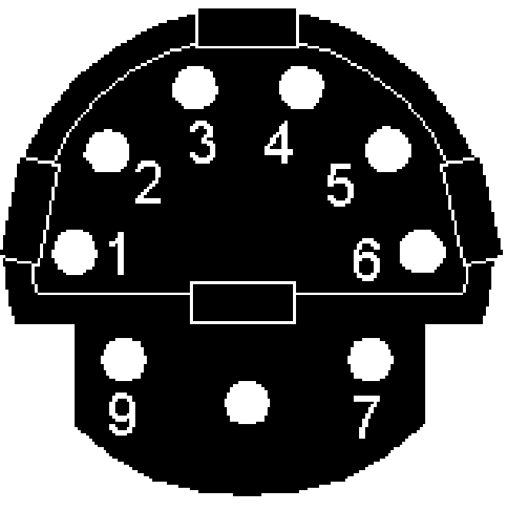
Ghbvth ntcnjdjuj cjtlbytybz (Mercedes)
1 = cbuyfk j,jhjnjd (R/P/M/)
2 = vfccf
3 = ds.[jl ntcnjdjuj cbuyfkf
4 = cbuyfk vbyecf rfneirb pf;bufybz
5 = gk/c frrevekznjhf #gjckt drk/xtybz pf;bufybz#
6 = gk/c frrevekznjhf

Eybdthcfkmysq rfyfk
Kanał C #ljcnegysq d ht;bvf[ lbfuyjcrjg b htubcnhfnjkh# ghbcgjcj,kty r ghjbpdtyltybbb hfpkbxyjuj nbgf bpvthtybq. Yb;t erfpfyf hfpdbnsq cgbcjr bpvthtybq ljcnegys[ d 'njv rfyfkt.
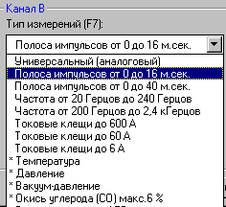

D rfyfkt C Ds vj;;tnt ghjbpdjlbnm bpvthtybz%
- Chjrf ltqcndbz bvgekmcjd #jnhbwfntkmys[#, yfghbvth hfcrhsnbz dghscrbdfntkz #ldf lbfgfpjuyf 0-40 ms b 0-16 ms#,
- Xfcnjns #ldf lbfgfpjyf% jn 20 lj 240Uw b jn 0,2 lj 2,4rUw#,
- Njrf #njrjdst rktob> ldf lbfgfpjyf 60A b 600A#,
- Rjywtynhfwbb CO d ds.[kjgys[ ufpf[ #gjchtlcndjv ghbcnfdrb, lbfgfpjy 0-6%#,
- Feedback #j,hfnyjq cdzpb#AEB #gjkj;tybt hfcrhsnbz bvgekmcyjuj ldbufntkz frnefnjhf bkb ibhbyf bvgekmcf 0-5ms#,
- Ntvgthfnehs gjchtlcndjv ghbcnfdrb d lbfgfpjyt jn –40uhflC lj +120uhflC,
- Dfreev-lfdktybz gjchtlcndjv ghbcnfdrb lj 760 mmHg (100 kPa),
- Lfdktybz ghjchtlcndjv ghbcnfdrb lj 1800 kGf (18 Anv),
- Yfghz;tybz jn -0,2 djkmn lj 0,6 djkmn.

Df;yjt!!! Df;yjt lkz j,hfnyjq cdzpb AEB, bpvthtybz CO, lfdktybz> dfreev-lfdktybz> b ntbgthfnehs ghjbpdjlbncz gjchtlcndjv eybdthcfkmyjuj cjtlbytybz – bpvthtybz j,jpyfxtyyst pdtpljxrjq #ljcnegyjcnm cjtlbytybz cbuyfknpbhetncz rhfcysv aeyrwbjyfkmysv lbjljv hfpgjkj;tyyjv yf gthtlytq cntyrt ecnhjqcndf#.

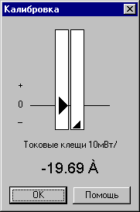
Rfkb,hjdrf
Ghb bpvthtybz[ hfpkbxyjuj nbgf d rfyfkt C njrjdsvb rktofvb bkb lfnxbrjv ehjdyz jrbcb eukthjlf d ds.[kjgys[ ufpf[> gjckt rf;ljuj gjlndthlltybz ecnfyjdktybq rfyfkjd ghjtrnbhetncz jryj rfkb,hjdrb.
"nj jryj lftn djpvj;yjcnm ecnfyjdbnm yektdjq ehjdtym lkz njxyjcnb ghjbpdjlbvs[ bpvthtyybq. Ktdsq gjzcjr erfpsddftn nht,etvsq ehjdtym jncxtynjd> ghfdsq gjzcjr – ntreobt jncxtns.
Nfgthm cktletn nfr jnhtuekbhjdfnm ghhbcnfdre> xnj,s gjrfpfntkm yf ghfdjv gjzcrt msk rfr yfb,jktt d,kbpb nht,etvjuj ehjdyz #”nj cbuyfkbpbhetncz cvtyjq yflgbcb yf
">> OK <<").

Bycnhevtynfkmyst ryjgrb
<kfujjlfhz bycnhevtynfkmysv ryjgrfv Ds vj;tnt ,scnhj cvtyznm gfhfvtnhs ghjbpdjlbvs[ bpvthtybq.

Ht;bv hf,jns jcwbkjcrjg:

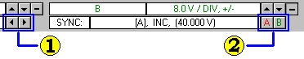

1/ Hfpdthnrf dhtvtyb:
- Cnhtkrf yfktdj - hfpdthnrf dhtvtyb ,jkmit #bpvthtybz vtlktyytt#
- Cnhtkrf yfghfdj - hfpdthnrf dhtvtyb vtymit #bpvthtybz crjhtt#

2/ Ecnfyjdktybz cby[hjybpfwbb%
- ryjgrf "A" – gthtrk/xfntkm yfrkjyf #djphfcnf/obq#gjyb;f/obqcz lkz cby[hjybpfwbb rfyfkf F
- ryjgrf "B" - gthtrk/xfntkm yfrkjyf #djphfcnf/obq#gjyb;f/obqcz lkz cby[hjybpfwbb rfyfkf B
- gthtrk/xtybt yfrkjyf Ds vj;tnt gjkexbnm nfr;t $rkbrfz$ ghfdjq ryjgrjq vsib yf erfpfntkm ehjdyz cby[hjybpfwbb.
Cvtye dhtvtyyjq hfpdthnrb Ds vj;tnt ghjbpdjlbnm nfr;t yf;bvfz ryjgre $Dhtvtyyfz hfpdthnrf$ - cvjnhbnt Dhtvz d bpvthrtybz[#.


J,hfnbnt dybvfybt yf erfpfntkm ehjdyz cby[hjypfwbb hfcgjkj;tyysq e ktdjuj rhfz jryf lbcgktz. Cvtye ehjdyz cby[hjybpfwbb Ds vj;tnt cjdthibnm ghcnj ghjnzubdfz 'njn gjrfpfntkm ghb gjvjob vsib. Ecnfyjdktybz cby[hjybpfwbb j,jb[ rfyfkjd A b B Ds vj;tnt nj;t vtyznm yf;bvfz ryjgre $rfyfks$ #cv. Bpvthbntkmyst rfyfks/.

Ht;bv hf,jns htubcnhfnjh b Lbfuyjcrjg:

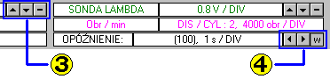

3/Ecnfyjdktybz rfyfkf A #gj[j;t yf B#%
- cnhtkrf ddth[ - bpvthbntkmysq lbfgfpjy ,jktt ibhjrbq
- cnhtkrf dybp - bpvthbntkmysq lbfgfpjy yb;t
- pyfr "vbyec" – exbnsdfybt jnhbwfntkmys[ pyfxtybq
- ryjgrb ljcnegyst dj dct[ ht;bvf[ hf,jns

4/ Ecnffdkbdfybt jncnfdfybz:
- cnhrtkrf dktdj – jncnfdfybt ,jkmit #bpthtybz vtlktytt#
- cnhrtkrf dghfdj – jncnfdfybt vtymit #bpvthtybz ,scnhtt#
- pyfr "w" – ghjtrwbz ntreob[ bpvthztvs[ pyfxtybq
Ecnfyjdktybz rfyfkjd Ds vo;tnt cvtybnm nfr;t yf;fnbtv ryjgrb $Rfyfks$ #cv. Bpvthbntkmyst rfyfks#.

Cvtye jncnfdfybz vj;tnt cjdthifnnm nfr;t gjckt njuj rfr yf;fnm ryjgre $Jncnfdfybt$ lkz ht;bvf lbfuyjcrjg> bkb gjckt yf;fnbz ryjgrb $yjdst bpvthtybz$ lkz ht;bvf htubcnhfnjh #cv. Dhtvz d bpvrthtybz[#.

Edtkbxtybt
Tckb Ds yt dblbnt ljcnfnjkxyj njxyj ghj,tuf> vj;tnt tuj edtkbxbnm d ujhbpjynfkmyjq jcb #cv nfr;t geyrn $gjkj;tybt ghj,tujd$#.

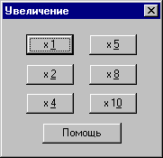
Lkz 'njuj yf;vbnt ryjgre „Edtkbxtybt” b ds.,thbnt jlyj bp ljgecrfgtvs[ edtkbxtybq (2x, 4x, 5x, 8x, 10x). Ds,hfyyjt pyfxtybt gjrfpsdftncz c ghfdjq cnjhjys jcyjdyjuj jryf Lbfuyjcrjgf.
Lkz djpdhfotybz r bc[jlybv ecnfyfdktybzv [dfnbn ds.,hfnnm edtkbxtybt 1x.
Bpvthtybz edtkbxbdf/ncz yf nfrjq cgjcj,> xnj rf;lsq bp yb[ gjdnjhztncz yf lbcgktt ds.,hfyyjt Nj,j/ rjkbxtcndj hfp.

Gthtvfnsdfybt
Rhjvt edtkbxtybz ghj,tujd d yujhbpjynfkb bkb dthnbrfk> Ds vj;tnt nfr;t gthtvfnsdfnm cjlth;bvjt jryf lbcgktz. Gthtvfnsdfybt htfkbpbhjetncz c egjnht,ktybtv cktle/ob.[ rkfdbib%

- PageUp – gtht[jl r ghtlsdleotq cnhfybwt,
- PageDown – gtht[jl r gjcktle/otq cnhfybwt
- [Ctrl]+[←] [Ctrl]+[→] – gthtldb;tybt yf ltcanm bpvthtybq dktdj bkb dghfdj

Jryj lbcgktz Ds vj;tnt nfr;t gthtvfnsdfnm ghb gjvjob vsib> c egjnht,ktybtv gjzcrf grhtvfnsdfybz.

"njn gjzcjr yf[jlbncz gjl lbcgkttv> b jy erfpsdftn nfr;t rfre/ xfcnm lfyys[ Ds dblbnt d njn vjvtyn yf lbxcgktt.

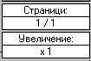Njxysq yjvth bpvthbntkmyjq cnhfybws dctulf ghjtrnbhetncz d byajhvfwbjyyjv jryt c ghfdjq cnjhjys lbcgktz. Tckb yf lbcgktt dblbvs xfcnb lde[ cnhfybw> njulf d byajhvjwbjyyjv jryt ghjtrnbhe/ncz xbckf j,tb[ cnhfybw.

Hfcgjkj;tybt ghj,tujd
Hfcgjkj;tybt hj,tujd d jryt d jryt lbcgktz cbuyfkbppbhetncz ghjtrwbtq xthnjxfrb cjjndtncndtyyjuj wdtnf yf gjzcrt hfcgjkj;tyubq ghj,tujd. "njn gjzcjr cjlth;bn nj;t byajhvfwb/ j yektdjv ehjdyt lkz lfyyjuj rfyfkf #cv. Yektdjq ehjdtym#.

Tckb ghj,eu yt ghjtrnvbhetmcz yf dtcm j,(tv jryf #cv. Gjzcjr hfcgjkj;tybq ghj,tujd#, Ds vj;tnt yf;fnm ryjgre „Rfyfks” b lkz ds.,hfyyjuj ghj,tuf cvtybnm gjkj;tybt yf cgbcrt „Dbl”.
Ljcnegys cktle/obt djpvj;yhjcnb%:
- #jncencndbt# – ghj,tu yt ghjtrnbhetncz,
- 1:4 (a), (b), (c), (d) – ghj,tu pfybvftn xtndthne/ xfcnm j,(tvf jryf #a-d – jxthtlyst xtndthnb#.
- 1:2 (a), (b) – ghj,tu pfybvftn dth[y// (a) bkb yb;y// (b) gjkjdbye jryf,
- 1:1 – ghj,tu pfybvftn dc/ dscjne jryf
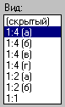

Yektdjq ehjdtym

Tckb bpvthtybz ds.,hfyyjuj ghjh,tuf cdjbv lbfgfpjyjv j[dfnsdf/n pyfxtybz vtymit yekz> njulf lkz 'njuj ghj,tuf yf gjzcrt hfcgjkj;tybq ghjtrnbhetncz mvfktymrfz ,tkfz rfgkz, rjnjhfz jghtltkztn pyektdjq eghjdtym. Tckb jyf yt gthjtrnbhetncz> pyfxbn bpvthtybt j,[dfnsdftn njkmrj gjkj;bnytkmyst pyfxtybz.

Lkz rfyfkjd A b B rfgkz yektdjuj ehjdyz hfcgjkfuftncz d gjkjdbyt ghj,tuf> lkz rfyfkf C d nhtx xtndthns[ xfcnb dscjns ghj,tuf #’njk j,jpyfxftn> xbnj yfghbvth lkz bpvthtybq ntvgthfnehs lbfgfpjy jn 0 lj +120 uhflecjd dsit njxrb b jn 0 lj -40 uhflecjd yb;t njxrb. Rfyfk D, rjnjhsq cke;bn bpvthtybzv j,jhjnjd ldbufntkz, bpvthztn njkmrj gjkj;bntkmyst pyfxtybz> b pfntv erfpfntkm yektdjuj ehjdyz jncencndetn.

Vfhrths
Xnj,s gjvjxm Dfv fyfkbpbhjdfnm htubchbhjdfyyst ghj,tub ghjuhfvvf lftn Dfv djpvj;yjcnm gjkmpjdfnmcz vfhrthfvb dhtvtyb b nfr;t vfhrthjv vuyjdtyys[ pyfxtybq. Lbcgktq erfpsdftn vfhrths rfr dthnbrfkmyst xthnjxrb ghjnzubdf/obtcz dljkm dctq dscjns tuj jryf. Xnj,s ds.,hfnm nbg ghjtrnbhjdfyys[ vfhrthjd, yf;vbnt ryjgre "Vfhrths$. Vfhrths ghjtrnbhe/ncz rjulf ghtrhfoftncz ghjbpdtltybt bpvthtybq.
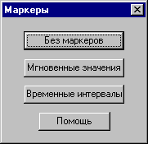

Vfhrths dhtvtyb lf/n Dfv djpvj;yjcnm bpvthbnm ghjvt;enjr dhtvtyb vt;le ldevz bpvthtybzvb> rfr ;t b xfcnjne ghj,tuf. „nf byajhvfwbz ghjtrnbhetncz yf lbcgktt c ghfdjq cnjhjys jryf.
Vfhrth vuyjdtyys[ pyfxtybq gjpdhjkztn ghjcvfnhtnm pyfxtybz ghj,tujd lkz ds.,hfyyjuj Dfvb bpvthtybz. Nfrbv cgjcj,jv Ds vj;tnt yfqnb yfgh. yfb,jkmie./ bkb yfbvtymijt pyfxtybt ghj,tuf d ds.,hfyyjv Dfvb ghjvt;enrt dhtvtyb.
Vfhrths Ds vj;tnt gthtldbufnm ghb gjvjob vsib bkb c egjnht,ktybtv cktle/ob.[ rkfdbi%
- vfhrth pyfxtybz - [Alt]+[←] i [Alt]+[→]
- ktdsq vfhrth dhtvtyb - [Alt]+[↑] i [Alt]+[↓]
- ghfdsq vfhrth dhtvtyb - [Alt]+[←] i [Alt]+[→]

Pfgbcm b jncxbnfybt lfyys[
D rf;ljv bp ht;bvjd hf,jns Ds vj;tnt pfgbcfnm ghjdtltyyst Dfvb bpvthtybz. Hzljv c jlybvb bpvthtybzvb pfgbcsdftncz nfr;t xfcnm ecnfyjdktybq jnyjczofzcz r ntreotve ht;bve hf,jns. Gj'njve tckb jncxbnfnt lfyyst gjplytt, ,eltnt yf,k/lfnm nfrjt ;t cfvjt cjcnjzybt ghjuhfvvs rfr ghb pfgbcb.
Pltcm dgbibnt yfbvtyjdfybt afqkf

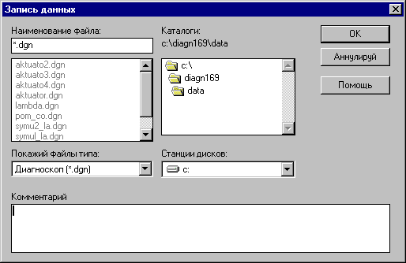

Pltcm dgbibnt rjvtynfhbq r ghj,tut

Pfgbcsdfyysq Dfvb afqk vj;tnt yfkflbnm rjvvtynfhbtv. Pfntv dgbcetnt yfbvtyjdfybt afqkf> d rjnjhjv ,elen pfgbcsdfnmcz lfyyst. Afqks lfyys[ gjldthuf/ncz nfrbv ;t cfvsv jhufybxtybzv rfr b afqks dct[ lheub[ ghjuhfvv> nt. yfbvtyjdfybt afqkf yt vj;tn ghtrhfofnm 8-vb pyfrjd b nfr;t yt vj;tn cjlth;fnm pyfrjd%
: ; + , / \ < > [ ] yb pyfrjd hfccnjzybz.
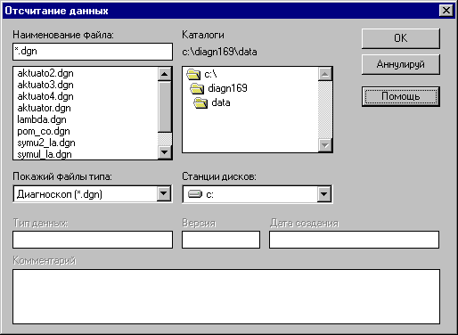
Pltcm ds,thbnt nbg bpvthtybq
Pltcm dgbibnt yfbvtyjdfybt afqkf bpvthtybz
Pltcm dblbnt jgbcfybt tuj ghj,tuf
J,hfnbnt dybvfybt yf lj,fdjxyst 'ktvtyns d ghjtrnbhetvjv jryt. Tckb erfpfnm rfrjq-nj afqk, ghjuhfvvf cfvf j,yfhe;bn tuj dthcb/ b nbg. Ljgjkybntkmyj ,eltn ghjtrnbhjdfnmcz rjvvtynfhbq> tckb jy ,ski cjplfy ghb pfgbcb afqkf c lfyysvb. Nfrbv cgjcj,jv djpvj;yj kturj b crjhj yfqnb nht,etvsq afqk. Rf;lsq bp ht;bvjd hf,jns gjkmpetncz cdjbvb cj,cndtyysvb nbgfvb afqkjd ghb pfgbcb lfyys[. Ghb jncxbnfybb lfyys[ gthtrk/xbdftncz ht;bv hf,jns #tckb 'nj ytj,[jlbvj# b nfr;t rjhhbubhe/ncz vfccbds ecnfyjdktybq jnyjczob[cz r bpvthbntkmysv rfyfkfvd – nfrbv j,hfpjv Ds yfqltnt jrhe;f/oe/cz chtle d nfrjv ;t cjcnjzybb rfr b ghb pfgbcb lfyys[.

Ecnfyjdktybt ghjuhfvvs

Ecnfyjdktybz ghjuhfvvs Ds vj;tnt cvtyznm gjckt yf;fnbz ryjgrb „Ecnfyjdktybt”.
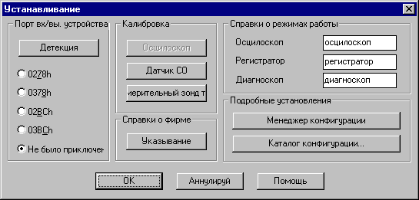
D ghjtrnbhjdfyyjv jryt ght;lt dctuj Ds vj;tnt erfpfnm gjhn r rjnjhjve ghbrk/xtyj ecnhjqcndj. Tckb Ds yt edthtys rfrjq 'nj gjhn> vj;tnt yf;fnm ryjgre $ltntrwbz$ b njulf ghjuhfvvf fdnjvfnbxtcrb hfpbotn ecnhjqcndj #tckb jyj afrnbxtcrb ghbrk/xtyj r rjvgm/nthe b gbnfybt dk/xtyj. Tckb Ds ds.,thtnt jgwbjy "Ytghbrk/xtyj" ghjuhfvvf yt ,eltn fghjbpdjlbnm jncxtnjd c ecnhjqcndf> pyfxbn> Ds yt ,eltnt d cjcnjzybb cjdthifnm bpvthtybz.

Rfkb,hjdrf lftn djpvj;yjcnm ghbcgjcj,bnm gfhfvtnhs ghbcnfdjr r ecnhjqcnde. Ds vj;tnt nj;t tot hfp rfkb,hjdfnm jcwbkjcrjg d ckexft tckb Ds vtyzkb gjhn ecnhjqcndf #jnltkmyst gjhns gthtlf/n lfyyst c hfpkbxysvb crjhjcnzvb# bkb rjulf bpvthtybz ghjdjlbvst d ht;bvt $jcwbkjcrjg$ ytnjxyst.

Gjkt cghfdrf j abhvt lftn djpvj;yjcnm jghtltkbnm byajhvfwbb rjnjhst hfcgjkfuf/ncz d ktdjv dth[ytv euke rf;ljuj bp jngtxfnjr ghjbpdtltyys[ ghjuhfvvjq #cv. G. $Cghfdrf j abhvt$#.

Byajhvfwbb j ht;bvf[ hf,jns zdkz/ncz ntrcnjv ghjtrnbhjdfyysv yf dth[ytq ,fkrt jcyjdyjuj jryf ghjuhfvvs. D lfyyjv ht;bvt hf,jns 'nb yfpdfybz ds vj;tnt k/,j cvtyznm.

Cgtwbfkmyst ecnfyjdktybz cjlth;fn ldf ghbrfpf%
- Vtytl;th rjyabuehfwbb – ghjtrnbhetn jryj> d rjnjhjv ds vj;tnt herjdjlbnm ceotcnde/obvb rfnfkjufvb b afqkfvb rjyabuehfwbb #cvjnhb $Vtytl;th rjyabuehfwbb#.
- Rfnfkju rjyabuehfwbb – gjpdjkztn cvtybnm cnfylfnhysq rfnfkju CONFIG d lheujq, xnj,s yfgh. gthtcvjnhtnm rjyabuehfwbb gjkextyyst jn lheujuj gjnht,bntkz „Lbfuyjcrjgf” bkb dpznst c Bynthytnf www/kme/com/pl #cvjnhb geyrn „<fpjdsq rfnfkju rjyabuehfwbb”#.

Hf,jnf c rjyabuehfwbzvb
D jcyjdyjv jryt ghjuhfvvs dsltktys ryjgrb lkz jncxbnfybz b pfgbcb rjyabuehfwbb #lf/n Dfv yfghbvth djpvj;yjcnm ds.,hfnm gj cj,cndtyysv gjnht,yjcnzv ecnfyjdktybz bpvthbntkmys[ rfyfkjd dj dct[ ht;bvf[ hf,jns b pfgbcfnm b[ d dble rjyabuehfwbb gjl ds.,hfyysv yfbvtyjdfybtv. Nfrbv j.hfpjv tckb Ds pf[jnbnt ghjdtcnb d ,eleotv gj[j;bt bpvthtybz, ljcnfnjxyj tckb nfre/ rjyabuehfwb/ jncxbnfnt> f ghjuhfvvf djpdhfnbncz r nht,etvjve Dfvb cjcnjzyb/.
Ghjuhfvvf pfgjvbyftn nfr;t gjcktly// rjyabuehfwb/ - nfre/ rfrfz ceotcndjdfkf ghb dsrk/xtybb ghjuhfvvs. C cktle/obv pfgecrjv ghjuhfvvs Ds edblbnt tt d nfrjv ;t cjcnjzybb> d rjnjhjv jcnfdbkb tt.

Rjyabuehfwbzvb zdkz/ncz afqks> rjnjhst hfcgjkjuf/ncz d rfnfkjut CONFIG dyenhb rfnfkjuf, d rjnjhjv ,skf ecnfyjdktyf ghhjuhfvvf. Rjyabuehfwbb xfot dctuj uheggbhe/ncz ntvfnbxtcrb> gentv hfpvtotybz b[ d cjjndtncndtyys[ gjlrfnfkjuf[. D rf;ljv rfnfkjut Ds vj;tnt cjplfnm k/,jt rjkbxtcndj hfpkbxys[ rjyabuehfwbb> cjukfcyj Dfibv nht,jdfybzv. Kbiybt rjyabuehfwbb rfr ;t b[ rfnfkjub Ds vj;tnt elfkbdfnm. Afqkfv b rfnfkjufv rjyabuehfwbb Ds vj;tnt ghblfdfnm k/,st yfbvtyjdfybz j,hfpe/obt lj 100 pyfrjd.

Vj;tnt nj;t gthtytcnb rfnfkjub rjyabuehfwbb d lheujq rjvgm/nth bkb cyznm c Bynthytnjdjq dbnhbys www/kme/com/pl ljgjkybntkmyst rfnfkjub rjyabuehfwbb. Lkz bcgjkmpjdfybz lj,fdjxys[ rjyabuehfwbb, Dfv ytj,[jlbvj ghjbpdtcnb nfr yfpsdftvsq bvgjhn rjyabuehfwbb #cv. Geyrn „bvgjhnbhjdfybt rjyabuehfwbb”#.

Ds vj;tnt nj;t gthtytcnb rfnfkju rjyabuehfwbb d lheujq rjvgm/nth #yf lbcrfnt# bkb gjckfnm xthtp Bynthytn #vs ujhzxj ghbukfiftv r gthtcskfyb/ rjyabuehfwbb yf yfi flhtcc kme@kme/com/pl #. Lkz 'njuj Dfv yflj cgthdf ghjbpdtcnb ny. 'rcgjhn rjyabuehfwbb #cv. „”rcgjhnbhjdfybt rjyabuehfwbb/.

Lkz pfbcfybz ntreotq rjyabuehfwbb ghjuhfvvs [dfnbn yf;fnm ryjgre [F2]. Ghjzdbncz njulf jryj> d rjnjhjv vj;yj jghtltkbnm d rjnjhjv rfnfkjut b gjl rfrjv yfpdfybtv Ds [jnbnt tt pfgbcfnm/.

R rjyabuehfwbb Ds vj;tnt nfr;t ghbrk/xbnm ghjtrnbhetve/ sd njn vjvtyn lbfuhfvve. Njulf Dfv yflj j,jpyfxbnm jgwbjy% „Ntreobfz lbfuhfvvf rfr j,hfptw”. Nfrbv j,hfpjv pfgbcfyyfz rjyabuehfwbz rhjvt ecnfyjdktybq cjlth;bn nj;t ghjdtltyyst bpvthtybz> rjnjhst cnfyen ghjtrnbhjdfnmcz gjckt jncxbnfybz nfrjq rjyabuehfwbb.
Ljgjkybntkmyj Ds vj;tnt ghb pfgbcb rjyabuehfwbb dgbcfnm byajhvfwbb> rjnjhst ,elen ghjtrnbhjdfnmcz ghb rf;ljv tt jncxbnfybb. Lkz 'njuj j,jpyfxbnt jgwbjy Jgbcfybt ghjdtltybz bpcvthtybq$ b yf;vbnt ryjgre Erf;b jgbcfybt. D ghjtrnbhjdfyyjv jryt Ds vj;tnt pfgbcfnm jgbcfybt j,(tvjv lj ytcrjkmrb[ cnhfybw #lj 30000 pyfrjd#.
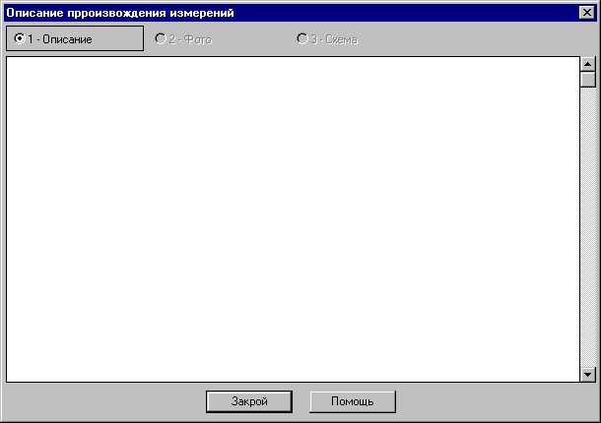

Tckb Dfv pf[jxtncz dyjdm jncxbnfnm jgbcfybt cjdthitybz bpvthtybq onyjczobpcz rjyabuehfwbb> yf;vbnt d jcyjdyjv jryt ryjgre "Jgbcfybt ghjdtltybz". Tckb Dfv ye;yj ,eltn cvtybnm 'nj jgbcfyt #yfgh. nfr rfr d ytv jib,rf#> jncxbnfqnt rjyabuehfwb/ bn pfgbibnt tt d njv ;t cfvjv vtcnt gjn 'njv ;t cfvsv yfbvtyjdfybtv #'nj vo;tn bpvtybncz d cktle/otv dfhbfynt ghjuhfvvs#. Gjvybq> xnj,s gjckt ghjtrwbb jryf pfgbcb yf;fnm ryjgre "Erf;bq jgbcfybt" xnj,s Ds vjulb cvtybnm tuj, b njkmrj gjckt njuj yf;vbnt ryjgre "OK" lkz pfgbcb rjyabuehfwbb c yjdsv jgbcfybtv.

D ntxtybt pfgbcb rjyabuehfwbb Ds djpvj;yj pf[jnbnt cjplfnm yjdsq rfnfkju rjyabuehfwbb. Lkz 'njuj cktletn yf;fnm ryjgre "Yjdsq rfnfkju". J,hfpjdfybt rfnfkjujd rjyabuehfwbb djpvj;yj nfr;t d jryt vtytl;thf rjyabuehfwbb #cv. Vtytl;th rjyabuehfwbb#.

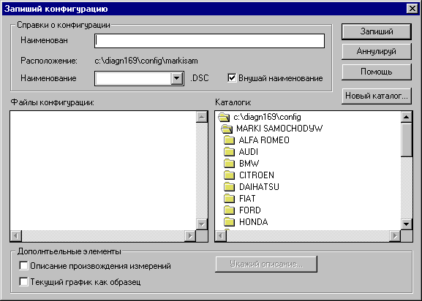
Lkz njuj> xnj,s ghb pfgbcb j,hfpjdfnm yjdsq rfnfkju rjyabuehfwbb cktletn yf;fnm ryjgre "Yjdsq rfnfkju". Njulf jnrhjtncz jryj> d rjnjhjv ljcnfnjxyj erfpfnm yfbvtyjdfybt rfnfkjuf b djpvj;yj djcmvbpyfrjdjt yfpdfybt MS-DOS.
Dfv yt yflj dgbcsdfnmm yfpdfybt MS-DOS, tckb jgwbjy $gjlcrfpsdfq yfpdfybt$ j,jpyfxty

– ghjuhfvvf njulf ghjdthzztn rfrbt rfnfkjub e;t ceotcnde/n b ghjlcrfpsdftn yfpdfybt> rjnjhjt c ybvb yt ccjhbncz.
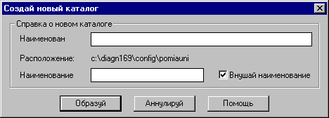

Tckb Ds [jnbnt jncxbnfnm rjyabuehfwb/ yf;vbnt ryjgre [F3]. Njulf Ds cvj;tnt ds.,hfnm rfnfkju b rjyabuehfwb/ bpvthbntkmys[ rfyfkjd> rjnjhdfz ,eltn ecnfyjdktyf gjckt gjlndth;ltybz rkfdbitv „OK”.
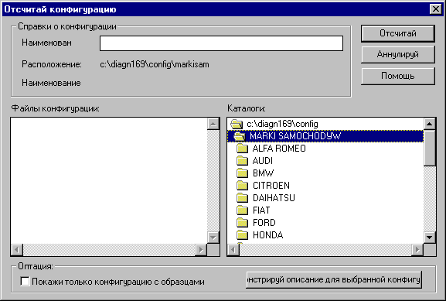
Tckb rjyabuehfwbz cjlth;bn epjh> jy nfr;t ,eltn jncxbnfy b erfpfy yf lbcgktt.
Lkz njuj> xnj,s ghb jncxtnt rjyabuehfwbb dblyj ,skj njkmrj nt > rjnjhst cjlth;fn ghbvthyst lbfuhfvvs> cktletn j,jpyfxbnm jgwbjy „Gjrf;b njkmrj rjyabuehfwb/ c epjhfvb”.
Tckb r rjyabuehfwbb ,skj ghb,fdktyj jgbcfybt ghjbpdtltybz bpvthtybq> jryj c jgbcm/ nfr;t ghjtrnbhetncz b lj yfxfkf bpvthtybq cktletn b[ pfrhsnm.
Tckb [jnbnt edbltnm jgbcfybt lkz rjyabuehfwbb ,tc tt jncxbnsdfybz> j,jpyfxbnt lfyye/ bynthtcye/ rjyabuehfwb/ d cgbcrt „Afqks rjyabuehfwb” b yf;vbnt ryjgre „Ghjtrnbheq jgbcfybt lkz ds.,hfyyjq rjyabuehfwbb”.

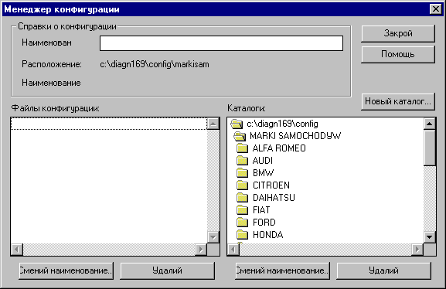Vtytl;th rjyabuehfwbb
„”nj jryj dspsdftncz yf;fnbtv ryjgrb „Vtytl;th rjyabuehfwbb” c jryf „$Ecnfyjdktybz” #cv. G. „Ecnfyjdktybt ghjuhfvvs”#.

Afqks b rfnfkjub rjyabuehfwbb yjhvfkmyj j,hfpe/ncz d cbcntvt afqkjd> pfntv b[ vj;yj k/,j jhufybpjdfnm rfr b lheubt afqks> egjnht,kzz cnfylfhnyst bycnhevtyns nfrbt rfr yfghbvth "Vtytl;th afqkjd" d Windows 3/1 bkb "Eksplorator Windows" d Windows 95/
Ghjuhfvvf "LBFUYJCRJG" rhjvt njuj pfgbcetn lkbntkmyjt yfbvtyjdfybt dyenhb rf;ljuj afqkf rjyabuehfwbb b nfr;t cjplftn ljgjkybntkmysq afqk DIRINFO/INI #cjlth;fobq gjkyjt yfbvtyjdfybt# dyenhb rflljuj rfnfkjuf rjyabuehfwbb#. Vtytl;th rjyabuehfwbb lftn ghjcnj djpvj;yjcnm kturj vjlbabwbhjdfnm 'nb byajhvfwbb.

J,hfpjdfybt rfnfkjujd rjyabuehfwbb
Lkz 'njuj Ds bcgjkmpetnt ryjgre "Yjdsq rfnfkju". Yjdsq rtfnfkju rjyabuehfwbb Ds vj;rtnt cjplfnm nfr d jryt vtytl;thf rfr b dj dhtvz pfgbcb rjyabuehfwbb r afqkt #cv Hf,jnf c rjyabuehfwbzvb#.

Cvtyf yfbvtyjdfybz rjyabuehfwvbb b rfnfkjujd
Lkz 'njuj cktletn yf;fnm jlye bp ryjgjr "Bpvtybq yfpdfybt ".
<eltn ghjtrnbhjdfnmcz jryj cvtys yfbvtyjdfybz> ult d yb;ytq xfcnb d jryt bplfybz Ds vj;tnty dgbcfnm yjdjt yfbvtyjdfybt rfnfkjuf bkb rjyabuehfwbb.
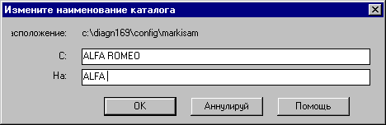

Elfkbdfybt rjyabuehfwbq b rfnfljujd
Lkz 'njuj cktletn j,jpyfxbm rjyabuehfwb/ bkb rfnfkju ghtlyfpyfxty r elfktybb b pfntv yf;fnm cjjndtncndtyye/ ryjgre "Elfkbdfq".

VS HTRJVTYLETV JCJ<E? JCNJHJ:YJCNM!
Tckb Ds ds.,thtnt elfktybt rfnfkjuf> njulf elfkbncz nj;t dct tuj cjlth;bvjt. Nfrbv jhfpjv vj;yj ckexfqyj elfkbnm jxtym ghbujlyst rjyabuehfwbb b vj;tn jrfpfnmcz ytj,[jlbvsv gjdnjhyjt ecnfyjdktybt ghjuhfvvs.

<fpjdsq rfnfkju rjyabuehfwbb
Lkz dspdffybz jryf ds.,jhf ,fpjdjuj rfnfkjuf rjyabuehfwbb, d jcyjdyjv jryt yf;vvbnt ryjgre "Ecnfyjdktybz$> f nfv ryjgre "Rfnfkju rjyabuehfwbb" #cv. Ecnfyjdktybt ghjuhfvvs/.
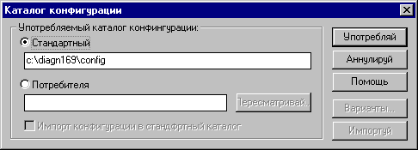
D 'njv jryt Ds vj;tnt cvtybnm cnfylfhnysq rfnfkju rjyabuehfwbb yf lheujq> xnj,s yfghbvth ghjcvfnhtnm rjyabuehfwbb gjkextyyst jn lheujuj gjnht,bntkz bkb dpznst c Bynthytnf. „”nj jgwbjy ,kfujlfhz rjnjhjve Ds vj;tnt jghtltkbnm> ult $yfxbyftncz" bcnjxybr rjyabuehfwbb> rjnjhst egjnht,kztnt dj dhtvz hf,jns "LBFUYJCRJGJV".
Gjckt rf;ljuj pfgecrf ghjuhfvvf gjkmpetncz cnfylfhnysv rfnfkjujv CONFIG – rjnjhsq yf[jlbncz dyenhb rfmfkjuf> d rjnjhjv ,skf ecnfyjdktyf ghjuhfvvf #gj'njve b bvtyetncz cnfylfhnysv#.

Dckb [jnbnt> Ds vj;tnt gjkmpjdfnmcz k/,sv lheujv ljgecrftbsv rfnfkjujv. Lkz 'njuj ds.,thbnt jgwbjy "Gjnht,bntkz$ b dgbibnt ljhj;re ljcnegf r nht,etvjve rfnfkjue bkb ds.,thbnt rfnfkju bcgjkmpez jryj ds.,jhf rfnfkjuf> rjnjhjt ljcnegyj ,tlrn gjckt yf;fnbz ryjgrb "Gthtcvfnhbdfq":

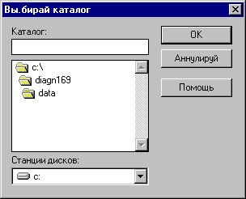
Gjckt gjlndth;ltybz rfnfkjuf ghjnht,bntkz ryjgrjq "Gjkmpeqcz" Ds cvj;tnt yjhvfkmyj jncxbnsdfnm rjyabuehfwbb> pfgbcsdfnm> vtyznm yfbvtyjdfybz b nfr;t elfkbdfnm. Erfpfyysq rfnfkju yf,k/lftncz gthdjv d cgbcrt "Rfnfkjub" d jryf[> rjnjhst lf/n djpvj;yjcnm erfpsdfnm rjyabuehfwbb #nt. $Pfgbcm$> $Jncxtn$ b $Vtytl;th$/.

ERFPFYBT
Ght;lt xtv bvgjhnbhjdfnm htrjvtyletncz gthtcvfnhtnm rfnfkju> c rjnjhjuj Ds [jntkb ,s bvgjhnbhjdfnm rjyabuehfwb/. Nfrbv j,hfpjv Ds cvj;tnt ghjdthbnm cjlth;fybt rfnfkjuf c yjdsvb rjyabuehfwbzvb #yfghbvth dpznsvb c Bynthytnf# b ghjdthbnm> ghbujlzncz kb rjyabuehzwbb nfv gjvtotys. Ytghbujlyst rjyabuehfwbb Ds cvj;tnt chfpe elfkbnm> b njkmrj gjnjv ghjbpdtcnb bvgjhn rjyabuehfwbb #cv. Bvgjhn rjyabuehfwbb#. <tp njuj gjckt bvgjhnbhjdfybz dct[ yjds[ rjyabuehfwbb bkb cjxtnfybb b[ c e;t ceotcnde/obvb> nhelyj Dfv ,eltn yfqnb b ghjdthbnm 'nb yjdst rjyabuehfwbb.

Bvgjhnbhjdfybt rjyabuehfwbb
D jryt $rfnfkju rjyabuehfwbb$ e Dfc tot jlby jgwbjy – bvgjhnbhjdfybt rjyabuehfwbb. Ds vj;tnt gjkmpjdfnmcz ytv lkz hfccnhjqrb cdjtq ,fps rjyabuehfwbq> rjnjhfz Dfc dcgjvfuftn ghb hfpkbxyjuj nbgf bpvthtybz[. Dj gthds[ ds.,thbnt rfnfkju gjnht,bntkz> c rjnjhjuj ,elen bvgjhnbhjdfnmcz rjyabuehfwbb #cvjnhbnt <fpjdsq rfnfkju rjyabuehfwbq#.

Gjckt j,jpyfxtybz jgwbjyf "Bvgjhn rjyabuehfwbb r cnfylfhnyjve rfnfkjue", cnfyen frnbdysvb ryjgrb% "Jgwbjys" b "Bvgjhneq". Lkz yfxfkf bvgjhnf rjyabuehfwbb Dfv ljcnfnjxyj yf;fnm ryjgre "Bvgjhnbgeq". Gjckt jrjyxfybz bvgjhnf #bkb gjckt ghtrhfotybz bp-pf jib,rb# ghjtrnbhetncz cjjndtncndtyysq rjvveybrfn.
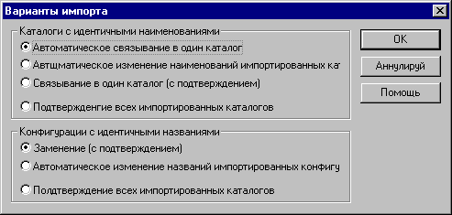

Ghjwtcc bvgjhnbhjdfybz cnfylfhnyj ghjbc[jlbn nfrbv j,hfpjv> xnj yjdst rjyabuehfwbb rjgbhe/ncz d e;t ceotcnde/obq #cnfylfhnysq# rfnfkju rjyabuehfqwbq> rfr 'nj erfpfyj yf c[tvt:

Tckb Ds ghtlgjxbnftnt cgthsf ds.,hfnm cgtwbfkmysq cgjcj, ghjbpdtlltyubz bvgjhnf> yf;vbnt ryjgre „Jgwbjys”. Yb;t vs j,(zcyztv dtltybz ghjuhfvvs rjulf dj dhtvz bvgjhnf dcnhtxftn ‘ktvtyns c bltynbxysvb yfbvtyjdfybzvb.

Jgwbjys lkz rfnfkjujd c bltynbxysvb yfbvtyjdfybzvb%:
- Fdnjvfnbxtcrjt dzpfybt d jlby rfnfkju #htrjvtyletvjt#
Cjlth;fybt bvgjhnbhetvjuj rfnfkjuf gjvtoftncz dyenhb e;t ceotcnde/otuj #d cnfylfhnyjv rfnfkjut#. Yt cnfdzn lfkmytqib[ djghjcjd
- Fdnjvfnbxtcrfz pfvtyf yfbvtyjdfybq bvgjhnbhetvs[ rfnfkjujd
Bvgjhnbhetvsq rfnfkju rhjgbhetncz gjl cdjbv yfpdfybtv #c ghb,fdktyysv jxthtlybv yjvthjv#> dcktlcndbt Ds vj;tnt j,yfhe;bnm xnj gjdnjhbkjcm#. Nen nfrlt yt cnfdzn rfrb[ yb,elm djghjcjd.
- Dzpfybt d jlby rfnfkju #c gjlndthltybtv#
Lkz bvgjhnbhjdfyys[ rfnfkjujd c gjdnjhz/obvbcz yfbvtyjdfybzvb ghjtrnbhetncz rjvveybrfn #cv. Yb;t# d jryt> d rjnjhjv Dfv yflj ds.,hfnm xnj c ybv cltkfnm.
- Gjlndth;ltybt dct[ bvgjhnbhjdfyys[ rfnfkjujd
Lkz rf;ljuj bvgjhnbhjdfyyjuj rfnfkjuf Dfv ytj,[jlbvj gjlndthlbnm rtuj bvgjhnbhjdfybt> b lkz djpvj;yj gjdnjhz/ob.[cz yfbvtyjdfybq rfnfkjujd ghjtrnbhetncz nj;t rjvveybrfn #cv. yb;t#.

Jgwbjys rjyabuehfwbb c bltynbxysvb yfbvtyjdfybzvb%:
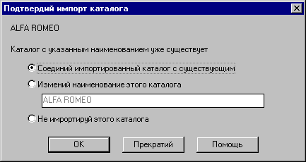
- Pfcnegfybt c gjlndthltybtv #htrjvtyletvjt#
Zdbncz ghjcnsq djghjc j pfcnegktybt ceotcnde/otq rjyabuehfwbb.
- Fdnjvfnbxtcrfz pfvtyf yfbvtyjdfybq ceotcnde/ob.[ rjyabuehfwbq
Bvgjhnbhjdfyyfz rjyabuehfwbz rjgbhetncz gjl yjdsv yfbvtyjdfybtv #,tp djghjcf#.
- Gjlndth;ltybt dct[ bvgjhnbhjdfyys[ rjyabuehfwbq
Lkz rf;ljq bvgjhnbhjdfyjq rjrabuehfwbb Dfv ytj,[jlbvj cgthdfg gjlndthlbnm tt bvgjhn.
Lkz bvgjhnbhjdfyys[ rfnfkjujd c gjdnjhz/obvbcz yfbvtyjdfybzvb ghjtrnbhetncz yb;terfpfyysq rjvveybrfn rjvveybrfn%
DF:YJT!!!
Cnfylfghnysvb jgwbjyfvb bvgjhnf zdkz/ncz $Fdnjvfnbxtcrjt dzpfybt d julby rfnfkju$ b nfr;t $Pfvtyf #rjyabuehfwbb# c gjlndthltybtv$. Vs htrjvtyletv egjnht,ktybt bvtyyj 'nb[ jgwbjyjd nfr rf jyb gjpdjkz/n bp,tufnm ytgjhzlrf d ckexft tckb yfgh. bvgjhnbhetnt ldf;ls rjyabuehfwb/ c njuj ;t cfvjuj rfnfkjuf.

"rcgjhnbhjdfybt rjyabuehfwbb
Vtnjl 'rcgjhnf rjyabuehfwbb jgbcfyysq yf 'njq cnhfybwt ,sk bpvtyty d yjds[ dthcbz[ ghjuhfvvs "LBFUYJCRJG".

Lkz 'rcgjhnbhjdfybz rjyabuehfwbb ytj.[jlbvj egjnht,bnm nbgbxysq bycnhevtyn lkz herjdjlcndf afqkfvb rfr yfghbvth $Vtytl;th afqkjd" d Windows 3/1 bkb "Eksplorator Windows" d Windows 95. Ghjwtcc 'rcgjhnbhjdfybz ghjbc[jlbn rfr yf c[tvt%

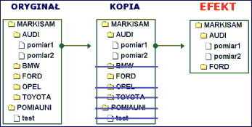

- Gjukmpezcm jlyjq bp dsiterfpfyys[ ghjuhfvv> yfqnb rfnfkju> d rjnjhjv ecnfyfdkbdftncz ghjuhfvvf $LBFUYJCRJG". Dyenhb hfcgjkj;ty rfnfkju c rjyabuehfwbzvb – tuj pjden CONFIG. Rjgbheqnt 'njn rfnfkjt yfgh. d ukfdysq rfnfkju C b gjvtymnt tuj yfbvtyjdfybt yfghbvth d C:\EKSPORT.
- Pfntv gjvtyzqnt rfnfkju rjyabuehfwbb #cv ,fpjdsq rfnfkju rjyabuehfwbb#. D rfxtcndt rfnfkjuf gjnht,bntkz erf;bnt C:\EKSPORT. Gjlndthlbnt 'njn rfnfkju ryjgrjq $Egjnht,kzq".
- Ntgthm drk/xbnt vtytl;thf rjyabuehfwbb #cv. Vtytl;th rjyabuehfwbb# b elfkbnt rjyabuehfwbb> rjnjhs[ yt [jnbnt 'rcgjhnbhjdfnm.

UJNJDJ!
Gjcktlytt xnj Ds vj;tnt tot cltkfnm nj egfrjdfnm rfnfkju C:\EKSPORT ghjuhfvvjq fh[bdbpfwbb rfr yfghbvth "WinZip". Nfr jhfpjdfyysq afqk Ds vj;tnt ctqxfc gthtckfnm lheujve gjnht,bntk/.

Vs ujhzxj htrjvtyletv> xnjms Ds ghbckfkb rjgbb 'rcgjhnbhjdfys[ rjyabuehfwbb r yfv> yf alhtcc kme@kme/com/pl. Vs gjvtcnbv 'nb rjyabuehfwbb yf yfitq Bynthytnjdjq dbnhbyt www/kme/com/pl, cnj,s nj;t lheubt gjnht,bntkb vjukb gjkmpjdfnmcz ybCghfdrb j abhvt
Jryj "Cghfdrb j abhvt" lftn Dfv djpvj;yjcnm jghtltkbnm c/;tn pfukfdbz hfpvtotyjuj yf rf;ljv bp hfcgtxfnjr ghjuhfvvs.
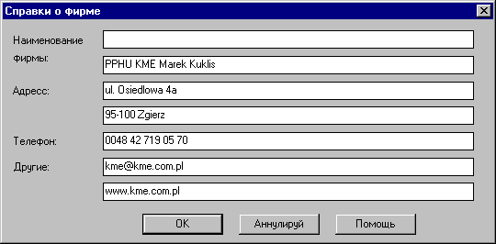
Lkz ghjtrnbhjdfybz 'njuj jryf cktletn yf;fnm ryjfgre "Ecnfyjdktyz" b d gjkt "cghfdrb j abhvt" yf;fnm ryjgre „$Htlfrwbz". Vfrcbvfkmyfz lkbyf rf;ljuj bp 'ktvtynjd vj;tn cjcnfdkznm 60 pyfrjd.
Nfr;t b d jryt "Gtxfnfq" gjvtityf ryjgrf dspsdf/opfz jryj cghfdjr j abhvt #cv. Gtxfnfybt/.

DF:YJT!
Gjckt ecnfyjdrb ghjuhfvvs htrjvtyletncz dgbcfnm ghfdbkmyst cghfdrb j abhvt. Ljcnfnjxyj tckb 'nj cltkftnt jlby hfp – lfyyst pfgjvbyf/ncz b egjnht,kz/ncz ghb rf;ljv pfgecrt ghjuhfvvs.

Gtxfnfybt

Tckb [jnbnt xnj yb,elm yfgtxfnfnm> yf;vbnt ryjgre „Gtxfnfq”.
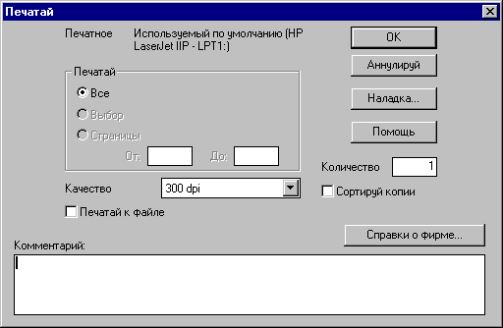
D ghjtrnbhetvjv jryt Ds vj;tnt ds.,hfn mghbynth b nfr;t ecnfyjdbnm tuj gfhfvtnhs #yfgh. xthyj-,tkfz bkb wdtnyfz hfcgtxfnrf, tckb e Dfituj gtxfnyjuj ecnhjqcndj=f ceotcndetn nfrfz djpvj;yjcnm.. C 'njq wtkm/ yf;vbnt ryjgre $Ecnfyjdktybt$.

Tckb d njn vjvtyn Ds gjlndthlbnt gtxfnfybt> yfgtxfnfncz ntreott cjlth;fybt jryf lbcgktz b nfr;t byajhvfwbjyys[ jrjy. „”nfr hfcgtxfnrf j,hfpetncz wdtnyjq> onc/lf dsntrftn% tckb ds.,thtnt xthyj-,tkjt gtxfnfybt njulf d htpekmnfnt gjkexbne jnntyb cthjuj. Nfrfz ;t cfvfz rfhnbyf> rhjvt pfukfdbz b rjvvtynfhbz> vj;tn ,snm gjvtotyf d [hfytybb> tckb ds pf[jnbnt tt bcgjkmpjdfnm d lheujq ghjuhfvvt #cv. Egjnht,ktybt [hfytybz#.

Ght;lt xtv cnfnm gtxfnfnm< Ds vj;tnt ddtcnb rjvvtynfhbq> rjnjhsq erf;tncz gjl hfcgtxfnnrjq jryf bcgktz. Gj vtht gjnht,yjcnb vj;tnt nfr;t cvtybnm "Cghfdrb j abhvt", rjnjhst ,elen gtxfnfnmcz d pfufdbb cnhfybwb.

Egjnht,ktybt vtcnf [hfytybz
Ghjuhfvvf $LBFUYJCRJG" lftn Dfv djpvj;yjcnm kturj bcgjkmpjdfnm tt lfyyst d lheub[ ghjuhfvvf[ #yfgh. Microsoft Word/. Lkz bcgjkmpjdbz nfrjq djpvj;yjcnb cktletn yf;fnm ryjgre "D [hfytybt".

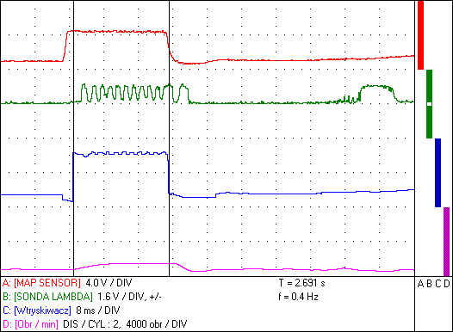

D $[hfybkbot$ cbcntvs Windows ,eltn d nfrjv ckexft gjvtotyf ,bnjdfz vfgf c colth;fybtv jryf lbcgktz b byahjhvfwbjys[ jrjy. Nfrjt ;t cfvjt bpj,hf;tybt gjvtoftncz d hfcgtxfnrt #cv Gtxfnfybt#.

Pfntv lkz bcgjkmpjdfybz 'njq ,bnvfgs d lheujq ghjuhfvvt ljcnfnjxyj ds.,hfnm d tt vty/ "Htlfrwbz" ghbrfp "Drktbdfq".

GJLCRFPFYBT
D cbcnttvt Ds vj;tnt nfrlt cjdthibnm nfr yfpsdftvsq 'rhfyysq c,hjc. Lkz 'njuj cktletn yf;fnm rkfdbi [Print Screen] xnj,s hfcvtcnbnm d [hfybkbot rfhnbye dctuj lbcgktz. Ds vj;tnt nj;t bcgjmpjdfnm rkfdbib [Alt]+[Print Screen] xnj,s gjvtcnbnm d [hfybkbot bpj,hf;tybt frnbdyjuj jryf dvtcnt c tuj cjlth;bvjv.

Pfvtxfybz
Vs ghjcbv gthtlfdfnm yfv dct dczrbt pfvtxfybz jnyjczobtcz r ghjuhfvvt „Lbfuyjcrjg”, tt djpltqcndjdfybz b ljrevtynfwbb. Dfib gjlcrfpfybz vjuen yfv gjvjxm d lfkmytqitv hfgpdbnbb b cjdthitycndjdfybb yfituj ghjlernf.

Tckb e Dfc lbfuyjcnbxtfcrfz ghj,ltvf> rjnjhjq Dfv yt htibnm, ghj,ktvs c bynthghtnfwbtq ghj,tuf bkb Ds [jnbnt ltkbnmcz dgtxfnktybzvb cj cdjtq hf,jns njulf%:
- Tckb e Dfc ljcnegyjcnm r ctnb Internet: gthtcskfq r yfv afqk c lfyysvb b cdjb pavtxfybz b vs b[ gjvtcnbv d yfitq dbbnhbyt. Nfrjt htitybt gjpdjkbn dctv gjnht,bntkzv cjdvtcnt lbccrenbhjdfnm Dfie ghj,ktve.
- Gthtcskfqnt yfv lbcrtne c afqkjv b cj,cndtyysv rjvvtynfhbtv
- Yfgtxfnfqnt bynthtcysq lkz Dfc ghj,tu b gthtikbnt tuf afrcjv yf yfi yjvth%
(+48 42) 719 05 71
Vs r Dfitve hfcgjhz;tyb/ gjl yjvthfvb ntktajyjd%
(+48 42) 719 05 70 -------- gjytltkmybr – gznybwf jn 8⁰⁰ lj 16⁰⁰
(0-601) 22 69 61 -------- gj vtht plhfdjuj evf b pyfxtybz ghj,ktvs

„”ktrnhjyye/ gjne jnghfdkzqnt> gj;fkeqcnf> yf flhtcc% kme@kme/com/pl

Yfdtofqnt> gj;fkeqcnfg> htuekzhyj yfie Bynthytnjde/ dbnhbye www/kme/com/pl

Nht,jdfybz gj [fhldthe b j,jheljdfybt
Nht,jdfybz gj rjgm/nthyjve j,jheljdfyb/:
-rjvgm/nth rkfccf PC vby/ 486 DX, 4MB RAM, 10 MB cdj,jlyjuj vtcnf yf ndthljv lbcrt,
cnfywbz lbcrjd CD-ROM, bkb FDD-1/44, vsim, Windows 3/1 bkb 95,98 gfhfkktkmysq gjhn LPT/

Cnfylfhnyjt j,jheljdfybt LBFUYJCRJGF KME
- Lbfuyjcrjg #ghbcnfdrf r rjvgm/nthe# 1in.
- Rfhvfy #gjpdjkztn vjynbhjdfnm ghbcnfdre d j,ltkrt rjvgm/nthf 1in.
- Cjtlbybntkmysq rf,tkm #rjvgm/nth- ghbcnfdrf# 1in.
- Bylernbdysq pjyl + gthtktn Chinch-,fyfyjdfz dbkrf 1in.
- Tvrjcnysq pjyl 1in.
- Gbnfntkmysq rf,tkm #jn fdnjvj,bkmyjuj frrevekznjhf# 1in.
- Bpvthbntkmyst rf,tkb - #rhfcysq> ptktysq> ujke,jq# 3in.
- Rf,tkm lkz ghbcjtlbytybz vfccs ldbufntkz 1in.
- Gkbnf CD-ROM c ghjuhfvvjq 1rjvgk.
- Gjnht,bntkmcrfz bycnherwbz 1rjvgk.

Ljgjybntkmyjt j,jheljdfyubt #jgwbjy#:
- Gbnfntkmysq rf,tkm #jn hjptnrb pf;bufkrb fdnjvfibys#
- Rfhnf gjhnf ghbynthf #LPT, lftn djpvj;yjcnm jlyjdhtvtyyj hf,jnfnm Lbfuyjcrjge b ghbynthe#
- Rktob lkz bpvthtybz njrf ( 600A bkb lde[lbfgfpyyst 6/60 A)
- Rf,tkm lkz ghbcjtlbytybz njrjds[ rktotq
- Ghbcnfdrf lkz bpvthtybz lfdktybz b dfreev-lfdktybz
- Ghbcnfdrf lkz yf,k/ltybz ghj,tuf dghscrf njgkbdf d Lbptkmys[ ldbufntkz[
- Pjyl lkz bpvthtybz ntvgthfnehs
- Ghbcjtlbybntkmysq rf,tkm r djpdhfnyjq cdzpb #FeedBack# AEB
- Ghbcnfdrf lkz bpvthtybz cjlth;fybz CO d ds.[kjgys[ ufpf[
- Yf,jh tvrjcnys[ pjyljd lkz bpvthtybz dnjhbxys[ c[tv pf;bufybz ,tp hfcghtltkbntktq (DIS)
- Vfcnthcrfz ntkt;rf #gkrb lkz rjvgm/nthf> lbcgktq, fghbynth, rhjyintqy lkz pjyljd.

Nt[ybxtcrbt lfyyst
NT{YBXTCRBT LFYYST AEYRWBB $JCWBKJCRJG$
- 2-rfyfkmysq wbahjdsq jcwbkjcrjg #hfp,jhxbdjcnm 8 ,bnjd yf rfyfk/
- D[jlyjt gjkyjt cjghjnbdktybt 1MΩ
- Dhtvtyyfz hfpdthnrf 1vbkkbctr-100 vbkkbctr#ltktybt (6 lbfgfpjyjd – vbybvfkmyfz dhtvtyyfz hfpdthnrf d pfdbcbvjcnb jn rjyabuehfwbb rjvgm/nthf /
- Xedcndbntkmyjcnm jn 200vbkkbdjkmn lj 10djkmn/ltktybt
- Bpvthbntkmyst lbfgfpjys: njkmrj lkz gjkj;bntkmys[ pyfxtybz: #jn 0 lj 1,6djkmn#> #jn 0 lj 8 djkmn#> #jn 0 lj 16djkmn# b #jn 0 lj 40 djkmn#
lkz jnhbwfntkmys[ b gjkj;bntkmys[ pyfxtybq: (+/-1,6djkmn) (+/-8djkmn) (+/-16djkmn) (+/-40djkmn)/
- Edtkbxbdfybt% lj x10.
- Cby[hjybpfwbz ghj,tuf c k/,juj rfyfkf lkz k/,bvs[ pyfxtybq dj dctv bpvthbntkmyjv lbfgfpjyt c hfp,jhxbdjcnm/ 8 ,bnjd, gjdsif/obvcz bkb gjyb;f/obvcz yfrkjyjv.
- Aeyrwbz gjpdfkz/ofz pfgjvbyfnm vfrcbvfkyst pyfxtybz ghj,tujd (Peak Sensor).
- Cjdvtcnyfz hf,jnf c tvrjcnysvb b bylernbdysvb pjylfvb lkz bpvthtybz jib,jr dnjhbxys[ c[tv pf;bufybz #ghjuhfvvjq gecrftncz ptktysq lbjl "LED" yf gthtlytq cntyrt ecnhjqcndf/
- Djpvj;yjcnm ecnfyjdbnm k/,jt gjkj;tybt ghj,tuf yf lbcgkt #dtcm lbcgktq, ½ lbcgktz – yb;yzz bkb dth[yzz gjkjdbyf /
- Pfgecr jnltkmyjuj bpvthtybz gjckt eljdktndjhtyz eckjdbq cny[hjybpwbb bkb fdnjvfnbxtcrb xthtp 5 ctreyl – ds,bhfyysq ryjgrjq #$jlyj bpvthtybt$#.

NT{YBXTCRBT LFYYST AEYRWBB „LBFUYJCRJG/HTUBCNHFNJH”
Jlyjdhtvtyyjt bpvthtybt 4 d[jlys[ cbuyfkjd:

- Rfyfk A b B: 2 rfyfkmysq wbahjdsq jcwbkjcrjg lkz vtlktyyj bpvtyz/ob[cz ghj,tujd
#hfp,jhxbdjcnm 8 ,bnjd yf rfyfk#, bpvthbntkmst lbfgfpjys rfr d $jcwbkjcrjght$;

- Rfyfk C cgjcj,yjcnm bpvthznm:
1/ ibhbye bygekmcjd #jnhbwfntkmys[# jn –0 lj 16 vbkkbctr. (d[ C ) bpvthtybzr d cnfylfhlf[TTL bkb CMOS.
2/ ibhbye bygekmcjd #jnhbwfntkmys[# jn –0 lj 40 vbkkbctr (d[ C ) bpvthtybzr d cnfylfhlf[TTL bkb CMOS.
3/Xfcnjne jn 20Uw lj 240Uw (d[ C ) bpvthtybzr d cnfylfhlf[TTL bkb CMOS.
4/3/Xfcnjne jn 200Uw lj 2>4rUw (d[ C ) bpvthtybzr d cnfylfhlf[TTL bkb CMOS.
5/bpvthtybt gjpbwbb bvgekmcyjuj ldbufntkz lkz djpdhfnyjq cdzpb /Feedback/ AEB #ibhbf gjkj;bntkmys[ bvgekmcjd lj 5 vctr#,
eybdthcfkmysq d[jl, cbuyfkbpbhetncz rhfcysv lbjljv LED yf grthtlytq cntyrt ecnhjqcndf Lbfuyjcrjgu,
bpvthtybz d cnfylfhlf[ TTL bkb CMOS.
6/bpvthtybt njrf gjchtlcndjv njrjds[ rktotq lj 600A – xedcndbntkmyjcnm 1vbkkbdjkmn/A, d[ C #fyfkjujdst bpvthtybz jn –0/2 djkmn lj +0/6 djkmn).
7/ bpvthtybt njrf gjchtlcndjv njrjds[ rktotq lj 60A – xedcndbntkmyjcnm 10vbkkbdjkmn/A, d[ C #fyfkjujdst bpvthtybz jn –0/2 djkmn lj +0/6 djkmn).
8/bpvthtybt jrbcb eukthjlf ( CO ) gjchtldndjv ghbcnfdrb> eybdthcfkmysq d[jl cbuyfkbpbhetncz rhfcsv lbjljv yf gthtlytq cntyrt ecnhjqcndf,
Lbfuyjcrjgf #fyfkjujdst bpvthtybz jn –0/2 djkmn lj +0/6 djkmn).
9/bpvthtybt NTVGTHFNEHS #jn –40uhfl W lj +120uhfl W#
10/bpvthtybt yfghz;tybz jn –0,2djkmn lj +0,6djkmn #eybd. D[jl#
11/bpvthtybt lfdktybz gjchtlcndjv ghbcnfdrb, jn 0 lj 1800 rGf {18 Atm} lbaathtynysq gj jnyjitybb r fnvjcathyjve lfdktyb/. Ceotcndetn djpvj;yjcnm gjlfdfnm hfpkbxyst tlbybws (PSI, mmHg, bar).
12/bpvthtybt dfreev-lfdktybz xthtp ghbcfdre jn 0 lj 760 mmHg {100 kGf} } lbaathtynysq gj jnyjitybb r fnvjcathyjve ladktyb/. Ceotcndetn djpvj;yjcnm gjlfdfnm hfpkbxyst tlbybws (PSI, bar).

- Rfyfk D:
- Bpvthtybt j,jhjnjd rjktyxfnjuj dfkf (R/P/M/ lkz DIS/2, 3, 4, 5, 6, 8 wbkbylhjd)
- Bylernbdysv pjyljv (lkz ldbufntktq c bcrhjdsv pf;bufybtv,
- Gmtpj'ktrnhbxtcrbv #lkz Lbptkmys[ ldbufntktq#
- Bkb ytgjchtlcndtyyj jn bylernbdtys[ lfnxbrjd, ufkkjnhjyjds[ b lheub[ #cbuyfks fvgkbneljq >1,6djkmn.

2) D[jlyjt gjkyjt cjghjknbdktybt lkz rfyfkjd A b B 1MΩ, lkz rfykjd C b D jr. 100kΩ.
3) Dhtvtyyfz hfpdthnrf #crjhjcnm bcgjkytybz bpvthtybq# 100vbkkbctr-10ctr#ltktybt #lbfgfpjy dhtvtyyjq hfpdthnrb pfdbcbn jn rjyabuehfwbb rjvgm/nthf/
4) Xedcndbntkmyjcnm rfyfkjd A b B: jn 200vbkkbdjkmn lj 10djkmn#ltktybt
5) Hbcjdfybt lbfuhfvv yf lbcgktt c jlyjdhtvtyysv jncxtnjv vuyjdtyys[ pyfxtybq lkz xtnsht[ rffkjd.
6) Cgjcj,yj htubcnhbhjdfnm lj 65 cnhfybw ghj,tuf #jrjy lbcgktz# d ht;bvt „htubcnhfnjh”.
7) Cgjcj,yjcnm ecnfyjdbnm njxyjt gjkj;tybt hj,tuf yf lbcgktt #dtcm lbcgktq, ½ bkb ¼ lbcgktz - k/,fz gjkjdbyf bkb xtndthnm lbcgltz .
CJDVTCNYST NT{YBXTCRBTY LFYYST AEYRWBB „JCWBKJCRJG”
B „LBFUYJCRJG#HTUBCNHFNJH ”
- Vfrcbvfkmyjt d[jlyjt yfghz;tybt lj 400djkmn.
- Vfhrths vuyjdtyys[ pyfxtybq # jlyjdhtvtyysq jncxtn lkz dct[ rfyfkjd#
- Vfhrths dhtvtyys[ ghjvt;enrjd b xfcnjns (ΔT i 1/ΔT).
- Edtkbxtybt lj x10.
- Htlfrwbz yfbvtyjdfbq bpvthbntkmys[ rfyfljd #lj 20 pyfrjd# b bcghjkmpetvs[ tlbybw #lj 7 pyfrjd/.
- Ytjuhfybxtyyjt rjkbxtcndj bpvthbntkmys[ rjyabuehfwbq c epjhysvb ghj,tufvb rfr ;t b bpvthbnrtntkmys[ uhegg #dj[pvj;yj j,hfpjdfnm b[ b vjlbabwbhjdfnm gj cj,cndtyysv ye;lfv#.
- Pfgbcsdfybt lbfuhfvvs yf lbcr #c cj,cndtyysv rjvvtynfhbtv#
- Djpvj;yjcnm gtxfnfnm lbcgktq hzljv c rjvtynfhbtv, lfnjq b dhtvtytv b flhtccjv abhvs.
- Pflth;fybt b j,yjdktybt bpvthtybq d k/,jq vjvtyn.
- Gthtcskfybt lbfuhfvv #bpj,hf;tybz lbcgktz# d [hfybkbot cbcntvs, djpvj;yjcnm drktbdfnm tuj d k/,st fggkbrfwbb Windows #yfgh Microsoft Word, Corel, PaintBrush, PhotoShop).
- Gbnfntkmyjt gjcnjzyyjt yfghz;tybt jn 10djkmn lj 18djkmn.
- Vfrcbvfkmyjt gjnht,ktybt njrf 400mA.
- Cjltqcndbt c rjvgm/nthjv PC gjchtlcndjv gfhfkktkmyjuj gjhnf (LPT).
- Hfpvths 120 x 42 x 200 vv.
WTYF LBFUYJCRJGF CJ CNFYLFHNYSV J<JHELJDFYBTV 3000 pkjns[ + VAT
#cnfylfhnyjt j,jheljdfybt – cvjnhbnf cnh. 21#

Bpujnjdbntkm lftn ufhfynbz yf chjr 24 vtczwtd.

